Software Test Documentation

Version 3-2014-06-02

For

PlasmaGraph

|  |  |  |
| --- | --- | --- |
| Daniel E. Quintini |  | Gerardo A. Navas |
| Computer Science Undergraduate Program |  | Computer Science Undergraduate Program |

Polytechnic University of Puerto Rico

Electrical & Computer Engineering and Computer Science Department

June 02, 2014

Revision History

|  |  |  |  |
| --- | --- | --- | --- |
| **Name** | **Date** | **Reason For Changes** | **Version** |
| Daniel E. Quintini | 2014/05/15 | Document still lacks important information like test cases, test cases reports and conclusions. | 1-2014-04-24 |
| Daniel E. Quintini | 2014/06/02 | Removed all remaining TBD | 3-2014-06-02 |

Table of Contents

Revision History ii

Table of Contents iii

1. Test plan identifier 1

2. Introduction 1

2.1 Objectives 1

2.2 Background 1

2.3 Scope 1

3. Test items 2

3.1 System Packages 3

3.2 User Procedures 5

4. Features to be tested 6

5. Features not to be tested 8

6. Approach 8

6.1 Conversion testing 8

6.2 Job streaming testing 8

6.3 Interface testing 9

6.4 Performance testing 9

6.5 Regression 9

6.6 Comprehensiveness 9

6.7 Constraints 10

7. Item pass/fail criteria 10

8. Suspension criteria and resumption requirements 10

8.1 Suspension criteria 10

8.2 Resumption requirements 10

9. Test deliverables 11

10. Testing tasks 12

11. Environmental needs 16

11.1 Hardware 16

11.2 Software 16

11.3 Operating system 17

11.4 Security 17

11.5 Tools 18

11.6 Publications 18

12. Responsibilities 18

12.1 Plasma Visualization Team 18

12.2 Plasma Laboratory Team 19

13. Staffing and training needs 19

13.1 Plasma Visualization Team 19

13.2 Plasma Laboratory Team 19

13.3 Training 19

14. Schedule 19

15. Risks and contingencies 20

16. Approvals 20

# Test plan identifier

STD-2-2014-05-15

# Introduction

## Objectives

A system test plan for PlasmaGraph should support the following objectives:

1. Detail the activities required to prepare for and conduct the system test.
2. Communicate to all responsible parties the tasks that they must perform, and the schedule to be followed in performing those tasks.
3. Define the sources of information used to prepare the plan.
4. Define the tools and environment needed to conduct the system test.

## Background

Dr. Angel Gonzalez-Lizardo, director of the plasma laboratory at the Polytechnic University of Puerto Rico requested on August 2013 that two software developers started working on a software tool with the capability to make graph charts based on the information produced by the laboratory equipment. The information is stored in a file with MATLAB’s LEVEL 5 MAT-File format.

Gerardo A. Navas and Daniel E. Quintini developed the tool requested by Dr. Angel Gonzalez-Lizardo. Specific requirements are stated in the software requirements specification document (SRS-3-2014-05-14).

## Scope

This test plan covers a partial system test for PlasmaGraph. This means that testing will focus only on the functional requirements specified in section 2.2.1 of the requirements document (SRS-3-2014-05-14). The test plan will only include the core packages of the system which relay on the packages that will not be tested directly. The plan also includes all user procedures specified by the PlasmaGraph User Manual (UM-2-2014-05-28).

# Test items

All items to be tested belong to PlasmaGraph’s Alpha version. Package testing will be accomplished using Java’s JUnit testing framework and the resulting test suit will be included in PlasmaGraph as a test package. Results produced by this test package will be documented by Gerardo A. Navas from the Plasma Visualization Team. User procedure testing on the other hand will be done by Daniel E. Quintini from the Plasma Visualization Team and at least one student and one professor from PUPR’s plasma laboratory.

The following documents will provide the basis for defining correct operation:

* Software Requirements Specification (SRS-3-2014-05-14)
* Software Design Description (SDD r2)
* Software Project Management Plan (SPMP r1)
* PlasmaGraph User Manual (UM-2-2014-05-28)
* IEE Standard for Software Test Documentation (IEEE Std 829-1998)

## System Packages

| **Type** | **Package** | **Member name** |
| --- | --- | --- |
| **Source Code** | org.pvg.plasmagraph.tests.DataSetTest | testDataSet ()  testAdd ()  testRemove ()  testFind ()  testContains ()  testGet ()  testIsDouble ()  testIsDoubleInt()  testIsString()  testIsStringInt ()  testSize ()  testToXYGraphDataset ()  testToBarGraphDataset ()  testGetColumnLength ()  testAppendDataSet () |
| **Source Code** | org.pvg.plasmagraph.tests.GraphTest | testXYGraphs()  testBarGraph() |
| **Source Code** | org.pvg.plasmagraph.test.HeaderDataTest | testAdd()  testRemove()  testFind()  testContains()  testGet()  testIsDouble()  testIsString()  testIsDateTime()  testSize()  testPopulateData()  testPopulateGroupedData()  testMultipleFilePopulateData() |
| **Source Code** | org.pvg.plasmagraph.test.InterpolatorTest | testInterpolateLinear()  testInterpolateQuadratic()  testInterpolateCubic()  testInterpolateSpline() |
| **Source Code** | org.pvg.plasmagraph.test.MATTest | testToDataSet()  testToStringFile()  testEquals()  testPrint()  testMapFileSize() |
| **Source Code** | org.pvg.plasmagraph.test.OutlierSearchTest | testClusterScanning()  testMahalanobisDistance() |
| **Source Code** | org.pvg.plasmagraph.test.TemplateTest | testSaveAndOpenTemplate() |
| **Executable Code** | org.pvg.plasmagraph.test | FeatureTestSuite.java |

## User Procedures

The procedures detailed by the PlasmaGraph User Manual (UM-2-2014-05-28) will be tested by Daniel E. Quintini and at least two students, mentors, or professors from PUPR’s plasma laboratory. These user procedures correspond specifically to features described in section 4 and identified as TDS-01-01, TDS-02-01, TDS-02-02, TDS-02-03, TDS-02-04, TDS-02-05, TDS-02-06, TDS-01-02, TDS-01-03, and TDS-02-07.

# Features to be tested

| **Test Design Specification Number (TDS)** | **Description** |
| --- | --- |
| **TDS-01-01** | Read a MATLAB LEVEL 5 MAT-File and display its contents on screen. |
| **TDS-01-02** | Import data from a MATLAB LEVEL 5 MAT-File of at least 60,000KB and plot a set of X values against a set of Y values in 5 minutes or less. |
| **TDS-01-03** | Change the chart graph’s title, X axis label, and Y axis label. |
| **TDS-01-04** | Portability. Test features TDS-01-01 to TDS-01-03 and TDS-02-01 to TDS-02-07 in the following Operating Systems: Windows 7, Ubuntu Linux 14, and Mac OS X 10 |
| **TDS-02-01** | Plot a set of X values against a set of Y values. |
| **TDS-02-02** | Plot a set of X values against a set of Y values and draw the line that results from the linear interpolation of the plotted points. Then, determine the confidence level of the graph. |
| **TDS-02-03** | Plot a set of X values against a set of Y values and draw the line that results from the quadratic interpolation of the plotted points. Then, determine the confidence level of the graph. |
| **TDS-02-04** | Plot a set of X values against a set of Y values and draw the line that results from the spline interpolation of the plotted points. Then, determine the confidence level of the graph. |
| **TDS-02-05** | Plot a set of X values against a set of Y values and identify the outliers. |
| **TDS-02-06** | Plot a set of X values against a set of Y values grouped by a third set of values and draw the line that results from the linear interpolation of the plotted points for each set of X,Y points plotted as part of each group. Then, determine the confidence level of the graph. |
| **TDS-02-07** | Plot a set of X values against a set of Y values and save the produced graph as an image in PNG format. |
| **TDS-03-01** | Perform automated testing for packages described in section 3.1. |

# Features not to be tested

Reading files formatted as comma separated values (CSV) will not be tested because its existence doesn’t affect any functional requirement of PlasmaGraph at the time of delivery. For the same reason, features related to template files will not be tested by the end user.

# Approach

Daniel E. Quintini and Gerardo A. Navas will use the system documentation to prepare all test design, cases, and procedure specifications. By taking this approach, the accuracy and comprehensiveness of PlasmaGraph’s documentation will also be tested.

## Conversion testing

PlasmaGraph can read a MATLAB LEVEL 5 MAT-File and convert it into an object usable by the system. This object is called a “DataSet” and to make sure that it represents the same data as the original file, it will be submitted to a verification process where the following criteria is to be meet:

1. DataSet has the same amount of columns as variables in the original MATLAB LEVEL 5 MAT-File.
2. Each column in the DataSet object has a corresponding variable in the original MATLAB LEVEL 5 MAT-File and the values contained in each variable are also contained in the corresponding column of the DataSet object.

## Job streaming testing

A comprehensive set of values produced by the Mirror and Cusp Plasma Machine at the Polytechnic University of Puerto Rico and formatted as a MATLAB LEVEL 5 MAT-File should be used to test features specified by test design specification numbers TDS-01-01, TDS-02-01, TDS-02-02, TDS-02-03, TDS-02-04, TDS-02-05, TDS-02-06, TDS-01-02, TDS-01-03, and TDS-02-07.

Each one of the features mentioned above should be tested using at least two different MATLAB LEVEL 5 MAT-Files.

## Interface testing

Interface testing will cover features specified in section 4 as TDS-01-01, TDS-02-01, TDS-02-02, TDS-02-03, TDS-02-04, TDS-02-05, TDS-02-06, TDS-01-02, TDS-01-03, and TDS-02-07. The following items should be used in order to test the interface between PlasmaGraph and its end user which can be any student, mentor, or professors working at the PUPR plasma laboratory:

1. User Manual: Because the end user won’t be familiar with the product at the time of delivery, the Plasma Visualization Team created the PlasmaGraph User Manual (UM-2-2014-05-28) which can be used by any student, mentor, or professor at PUPR’s plasma laboratory to perform any of the tests covered in this section.
2. MTLAB LEVEL 5 MAT-Files: A team of students at PUPR’s plasma laboratory created two files using the output produced by the Mirror and Cusp Plasma Machine. These files are formatted as readable data files which are described in section 3.1.1.2 of the requirements documentation (SRS-3-2014-05-14).

## Performance testing

Performance testing will be evaluated against the requirements specified in section 3.3 of document (SRS-1-2014-01-23). This can be accomplish by importing data from a 60,000KB MATLAB LEVEL 5 MAT-File into PlasmaGraph and plotting a set of X values against a set of Y values as described in feature test TDS-01-02.

## Regression

Before a new version of PlasmaGraph is approved for delivery to the client, it needs to pass every test passed by the previous version. Test results from both versions also need to be compared so the developers can detect any unexpected impact resulting from program modifications.

## Comprehensiveness

Each of the features specified in the PlasmaGraph User Manual (UM-2-2014-05-28) has exactly one associated test design specification. The system’s core packages are also tested using Java’s JUnit testing framework and a resulting test suit package is included in PlasmaGraph’s source code so package testing can be repeated or adjusted at any time.

## Constraints

A final implementation date of May 20, 2014 has been planned for PlasmaGraph. It is necessary to meet this date because the current trimester at PUPR ends on May 26, 2014 and the students working at the plasma laboratory have to produce reports from graph charts generated by PlasmaGraph before the trimester ends.

# Item pass/fail criteria

Every item in the packages tested using Java’s JUnit testing framework should pass its corresponding unit test as defined in the test package source code. Likewise, every user procedure needs to pass the test designed for it and performed by the end user with the help of the User’s Guide for Testing PlasmaGraph (TDB). A user procedure test is considered to be passed if and only if the person performing the test comes up with exactly the same results as those specified by the section of the User’s Guide for Testing PlasmaGraph (TDB) that corresponds to the user procedure being tested.

# Suspension criteria and resumption requirements

## Suspension criteria

Inability to translate a MATLAB LEVEL 5 MAT-File into a DataSet object will result in suspension on all testing activities. Testing activities can also result in total suspension if a version of PlasmaGraph fails a regression test as defined in section 6.5.

## Resumption requirements

When the suspended version is re-introduced for testing, a regression test as described in section 6.5 is to be done.

# Test deliverables

The following documents will be generated by the Plasma Visualization Team and/or the students and professors from the Plasma Laboratory Team selected for testing PlasmaGraph.

***Test documentation:***

* System Test Design Specification
* System Test Case Specification
* System Test Procedure Specification
* System Test Summary Report

These documents must be delivered to Daniel E. Quintini from the Plasma Visualization team as soon as the test is completed.

***Test data:***

1. All data entered, inquired, and used by PlasmaGraph during testing must be copied and attached to its corresponding test case documentation. The tester must also specify in which operating system the test was executed.
2. Copies of both input and output files resulting from testing must to be delivered to Daniel E. Quintini from the Plasma Visualization team along with the test’s corresponding documentation.

# Testing tasks

| **Task** | **Predecessor tasks** | **Special skills** | **Responsibility** | **Effort** | **Finish date** |
| --- | --- | --- | --- | --- | --- |
| **(1) Prepare test plan.** | Complete Software Design Description (SDD r2) and PlasmaGraph User Manual (UM-2-2014-05-28) | Knowledge of IEE documentation standards.  Proficient in any word processing tool capable of producing documentation formatted as portable document file (PDF). | Plasma Visualization Team | 7 | 2014-05-01 |
| **(2) Prepare test design specifications.** | Task 1 | Knowledge of PlasmaGraph’s capabilities and components.  Proficient in any word processing tool capable of producing documentation formatted as portable document file (PDF). | Plasma Visualization Team | 9 | 2014-05-08 |
| **(3) Prepare test case specifications.** | Complete corresponding test designs (Task 2) | Knowledge of PlasmaGraph’s capabilities and components.  Proficient in any word processing tool capable of producing documentation formatted as portable document file (PDF). | Plasma Visualization Team | 7 | 2014-05-08 |
| **(4) Prepare test procedure specifications** | Complete corresponding test case specifications (Task 3) | Proficient in any word processing tool capable of producing documentation formatted as portable document file (PDF). | Plasma Visualization Team | 7 | 2014-05-08 |
| **(5) Generate the MATLAB LEVEL 5 MAT-Files used for testing.** | Software Design Description (SDD r2) | Experience programming in MATLAB |  | 6 | 2014-05-01 |
| **(6) Generate a Java executable file from PlasmaGraph’s source code** | Implement PlasmaGraph as defined by Software Design Description (SDD r2) and using Oracle’s Java programming language. | Experience programming in Java. | Plasma Visualization Team | 3 | 2014-05-08 |
| **(7) Deliver test items to everyone responsible for testing** | Task 4  Task 5  Task 6. | - | Plasma Visualization Team | - | 2014-05-12 |
| **(8) Execute package testing** | Task 7 | Experience using Java’s JUnit testing framework. | Plasma Visualization Team | 4 | 2014-05-16 |
| **(9) Execute user procedure testing** | Task 7 | - | Plasma Laboratory Team:  Student 1  Professor 1 | 3 | 2014-05-16 |
| **(10) Review test results** | Task 8  Task 9 | - | Plasma Visualization Team | 5 | 2014-05-19 |
| **(11) Resolve test incidents reports** | Task 10 | Experience programming in Java. | Plasma Visualization Team | 3 | 2014-05-19 |
| **(12) Repeat tasks (7)-(11) until every test incident report is resolved.** | Task 11 | - | Plasma Visualization Team | - | 2014-05-19 |
| **(13) Write the system test summary report.** | Task 12 | Knowledge of PlasmaGraph’s capabilities and components.  Proficient in any word processing tool capable of producing documentation formatted as portable document file (PDF). | Plasma Visualization Team | 3 | 2014-05-20 |

# Environmental needs

## Hardware

The testing will be done using 3 different computers:

Computer 1:

1. 15’’ Monitor
2. A standard alphanumeric American (QWERTY) keyboard
3. One 3.20GHz dual core processor
4. 8GB of RAM
5. Operating System: Windows 7 Professional

Computer 2:

1. 15.4’’ Monitor
2. A standard alphanumeric American (QWERTY) keyboard
3. One 2.53GHz dual core processor
4. 4GB of RAM
5. Operating System: Mac OS X 10

Computer 3:

1. 17.3’’ Monitor
2. A standard alphanumeric American (QWERTY) keyboard
3. One 2.40 GHz dual core processor
4. 4GB of RAM
5. Operating System: Linux Ubuntu 14

## Software

In order to run any test, Oracle’s Java SE Runtime Environment version 7 must be installed.

## Operating system

Because one of the functional requirements for PlasmaGraph is to be portable, every test described by this document must be performed 3 times. That is once in each of the following operating systems:

* Microsoft’s Windows 7
* Mac OS X 10
* Linux Ubuntu 14

## Security

Security will be limited to existing controls defined by the operating system.

## Tools

The following tools are required for generating, evaluating, and documenting the system’s tests:

1. Mirror and Cusp Plasma Machine
2. MathWorks’ MATLAB high-level language and interactive environment for numerical computation, visualization, and programming.
3. NetBeans IDE or Eclipse IDE.
4. Any word processor software capable of producing documentation formatted as a portable document file (PDF).

## Publications

The following documents are required to support system testing:

* Software Requirements Specification (SRS-1-2014-01-23)
* PlasmaGraph User Manual (UM-02-2014-05-28)
* Software Design Description (SDD r2)
* Software Project Management Plan (SPMP r1)

# Responsibilities

The following groups are responsible for segments of the testing:

## Plasma Visualization Team

This group performs the following functions:

* Provide overall management of the testing and the technical testing expertise.
* Provide the version of PlasmaGraph to be tested along with all necessary items for performing said test.
* Respond to the PlasmaGraph’s Test Incident Reports.
* Program debugging.
* Execute each test once.

## Plasma Laboratory Team

This group is the end user of PlasmaGraph and performs the following functions:

* Review test design specifications.
* Generate at least two MATLAB LEVEL 5 MAT-Files from PUPR’s Mirror and Cusp Plasma Machine output.
* Execute user procedure testing.

# Staffing and training needs

## Plasma Visualization Team

The team consists of two (2) computer science undergraduate students from the Polytechnic University of Puerto Rico.

## Plasma Laboratory Team

The team consists of five (5) professors, two (2) mentors and ten (10) students from the Polytechnic University of Puerto Rico.

## Training

Members of the plasma laboratory team that execute user procedure testing must be familiar with the PlasmaGraph User Manual (UM-2-2014-05-28).

# Schedule

Package testing will be done on April 25 and user procedure testing will be done from May 5 to May 9. See section 10 of this document for a full list of tasks and their delivery dates.

# Risks and contingencies

If the testing schedule is significantly impacted by system failure, the plasma visualization team will take on the task of debugging and will make this their first priority.

If the client Dr. Angel Gonzalez-Lizardo is not sufficiently available for testing he will identify another professor able to complete the testing.

# Approvals

|  |  |  |
| --- | --- | --- |
| Dr. Angel Gonzalez-Lizardo |  | Date |
|  |  |  |
| Daniel E. Quintini |  | Date |
|  |  |  |
| Gerardo A. Navas |  | Date |

**Attachments**

|  |  |
| --- | --- |
| 1. TDS-01-XX 2014-05-22 2. TCS-01-01 2014-05-22 3. TPS-01-01 2014-05-22 4. TSR-01-01 2014-05-22 5. TCS-01-02 2014-05-22 6. TPS-01-02 2014-05-22 7. TSR-01-02 2014-05-22 8. TCS-01-03 2014-05-22 9. TPS-01-03 2014-05-22 10. TSR-01-03 2014-05-22 11. TCS-01-04 2014-05-22 12. TSR-01-04 2014-05-22 13. TDS-02-XX 2014-05-22 14. TCS-02-01 2014-05-22 15. TPS-02-01 2014-05-22 16. TSR-02-01 2014-05-22 17. TCS-02-02 2014-05-22 18. TPS-02-02 2014-05-22 19. TSR -02-02 2014-05-22 20. TCS-02-03 2014-05-22 21. TPS-02-03 2014-05-22 22. TSR -02-03 2014-05-22 23. TCS-02-04 2014-05-22 24. TPS-02-04 2014-05-22 25. TSR -02-04 2014-05-22 26. TCS-02-05 2014-05-22 27. TPS-02-05 2014-05-22 28. TSR -02-05 2014-05-22 29. TCS-02-06 2014-05-22 | 1. TPS-02-06 2014-05-22 2. TSR -02-06 2014-05-22 3. TCS-02-07 2014-05-22 4. TPS-02-07 2014-05-22 5. TSR -02-07 2014-05-22 6. TDS-03-07 2014-05-22 7. TCS-03-07 2014-05-22 8. TPS-03-07 2014-05-22 9. TSR-03-07 2014-05-22 |

**System Test Design Specification**

1. **Purpose**

This document describes in more detail than the STD-2-2014-05-15 the process through which some of PlasmaGraph’s tests will be conducted.

1. **Outline**
   1. **Test Design Specification Identifier**

TDS-01-XX 2014-05-22

* 1. **Features to be Tested**

1. Inspect Data (NR-03) ***[see SRS-3-2014-05-15 section 2.2.2.3]***.
2. Import Data (FR-01) ***[see SRS-3-2014-05-15 section 2.2.1.1]***.
3. Choose Graph Options (FR-03) ***[see SRS-3-2014-05-15 section 2.2.1.3]***.
4. Portability ***[see SRS-3-2014-05-15 section 3.5.4]***.
   1. **Approach Refinements**
      1. **Testing Technique**

All features specified in section 2.2 of this document will be tested using the “Black Box” testing technique. This means that the testers will be oblivious of the system’s architecture and source code. The testers will interact with the system through its graphical user interface by providing inputs and examining outputs without knowing how and where the inputs are worked upon.

The black box testing technique was chosen for the following reasons:

* The testing comprises a very large segment of code.
* The testers need to be able to access all features being tested through a graphical user interface so access to the code is not required.
* The test must focus on the user’s perspective and not the developer’s. Visibly defined roles help achieve this goal.
  + 1. **Methods for Results Analysis**

To evaluate the success or failure of test cases derived from this specification, the output produced by the system at the end of each case must match the output described in section 2.5 of this document.

* + 1. **Common Test Cases Information**

All test cases derived from this specification (except that dealing with portability) must require that the testers repeats all test procedures using three (3) different operating systems and (3) different personal computers.

* 1. **Test Identification**

| Case Identifier | Description | Procedure |
| --- | --- | --- |
| TCS-01-01 | This case focusses on the particular feature where the user orders the system to read a MATLAB LEVEL 5 MAT-File and display its contents on screen.  This case covers feature A as mentioned in section 2.2. | The tester must import a data file into the system and then order the system to inspect the data. |
| TCS-01-02 | This case focusses on the system’s response time and “user friendliness”.  This case covers feature B as mentioned in section 2.2. | The tester must import a data file of 60,000KB into the system and plot a set of X values against a set of Y values in 5 minutes or less. |
| TCS-01-03 | This case focusses on how the system lets the user change the labels of the graph.  This case covers feature C as mentioned in section 2.2. | The tester must import a data file into the system, set a particular name for the chart graph’s title, X axis label, and Y axis label. Then the tester must order the system to make a graph using to sets of values. |
| TCS-01-04 | This case focusses on the system’s ability to function on more than 2 operative systems and more than two different personal computers.  This case covers feature D as mentioned in section 2.2. | The user must perform all other tests in 3 different computers and 3 different operative systems. |

* 1. **Features Pass/Fail Criteria**

Each feature will be considered a success if and only if it passes the following criteria for each of its cases:

* + 1. After running a case, the output provided to the tester by the system must match the expected output provided in the test case specification.
    2. No error messages are produced by the system unless the test case specification explicitly determines that an error message should be produced by the system.

**System Test Case Specification**

* 1. **Test Case Specification Identifier**

TCS-01-01 2014-05-22

* 1. **Test Items**

PlasmaGraph feature “Import Data” ***[see SRS-3-2014-05-15 section 2.2.1.1].***

* 1. **Input Specifications**

1. One (1) 60,000KB data file formatted as a binary MATLAB Level 5 MAT-File **[see *SRS-3-2014-05-15 section 2.2.1.1*].**
   1. **Output Specifications**
2. The system must show the following information:

|  |  |
| --- | --- |
| -- Column --  Name: ExperimentNumber  Type: double  Size: 5  Values: [NaN, 1.0, 1.0, 1.0, 2.0] | -- Column --  Name: CurrentLevelA  Type: double  Size: 5  Values: [50.0, 100.0, 150.0, 200.0, 250.0] |
| -- Column --  Name: Temperature2eV  Type: double  Size: 5  Values: [27.673172, 7.944175, 9.140306, 9.354156, 8.108458] | -- Column --  Name: PlasmaPotential2V  Type: double  Size: 5  Values: [44.4, 11.6, 12.8, 13.2, 12.0] |

* 1. **Environmental Needs**
  2. **Hardware**

A personal computer with the following minimal specifications is required to execute this case:

* 15’’ Monitor with a resolution of 1200x700 and refresh rate of 30Hz
* A standard alphanumeric American (QWERTY) keyboard
* Two 3.20Ghz microprocessors
* 500Mb of available HDD
* 512Mb of RAM
* One (1) USB 2.0 port
  1. **Software**

PlasmaGraph must be installed in the tester’s computer in order to perform this test case.

* 1. **Special Procedural Requirements**

This case must be executed in three (3) different operative systems as stated in the documentation STD-2-2014-05-15 these operative systems are:

1. Windows 7
2. Ubuntu Linux 14
3. Mac OS X 10

**System Test Procedure Specification**

* 1. **Test Case Specification Identifier**

TPS-01-01

* 1. **Purpose**

This procedure describes the steps necessary to perform the test specified in the test design specification for PlasmaGraph feature “Inspect Data” TCS-01-01 **[see *TDS-01-XX section 2.4*]**.

* 1. **Special requirements**

No special requirements are needed to execute this test.

* 1. **Procedure steps**

1. ***Execute PlasmaGraph***

In order to launch the application the tester must click on the PlasmaGraph icon.

1. ***Import the data file provided into PlasmaGrap***

To import the data file provided the tester have to click on the data option located in the top menu of the tool bar. After doing this a menu with two more options will appear. Click on “Import Data”.

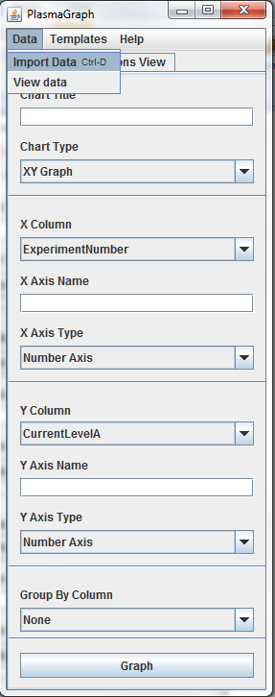

1. ***Inspect data***

To view the data contained in the file imported in step 4.2 the tester must click on data and then view data. These options are located in the tool bar as described in the figure below.

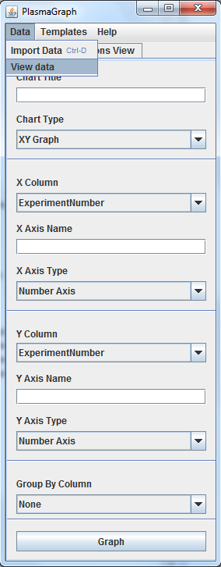

1. ***Compare outputs***

The tester must examine the data displayed by the program and determine if it complies with the expected output specified in the test case specification for this case ***[see document TCS-01-01 section 4]***.

1. ***Repeat for other OS***

Repeat steps 4.1 through 4.6 under the following operative systems:

1. Windows 7
2. Ubuntu Linux 14
3. Mac OS X 10

**System Test Summary Report**

* 1. **Test summary report identifier**

TSR-01-01 2014-05-22

* 1. **Summary**

The feature “Inspect Data” as defined in the requirements documentation ***[see SRS-3-2014-05-14 section 2.2.2.3]*** passed all its tests.

The following test documents are associated with this module:

* STD-2-2014-05-15
* TDS-01-XX 2014-05-22
* TCS-01-01 2014-05-22
  1. **Tester details**

|  |  |  |  |
| --- | --- | --- | --- |
| Name | Test Started | Test Ended | Signature |
|  |  |  |  |

* 1. **Variances**

Indicate if there were any deviations from the original agreements on which this feature was supposed to be tested.

|  |  |  |
| --- | --- | --- |
|  |  |  |
|  |  |  |

* 1. **Evaluation**

Refer to the test case specification document TCS-01-01 2014-05-22 section 4 and indicate if the output generated by this test match the expected output.

|  |  |  |
| --- | --- | --- |
| Expected output | Yes | No |
| 1. The data displayed by the program matches the output specified in the test case specification ***[see document TCS-01-01 section 4].*** |  |  |
| 1. Outputs a matched as expected using Windows 7, Ubuntu Linux 14 and Mac OS X 10. |  |  |

* 1. **Summary of results**

Indicate if the feature passed or failed the test. If it failed please indicate at which point and any possible cause for the issue.

|  |  |
| --- | --- |
|  |  |
|  |  |
|  |  |

* 1. **Approvals**

|  |  |  |
| --- | --- | --- |
|  |  |  |
|  |  |  |
| Daniel E. Quintini Greco |  | Date |

**System Test Case Specification**

* 1. **Test Case Specification Identifier**

TCS-01-02 2014-05-22

* 1. **Test Items**

PlasmaGraph feature “Import Data” and “Create Graph” **[see *SRS-3-2014-05-15 section 2.2.1.1 and 2.2.1.4*]**. This test will focus specifically in the product’s ability to import large files and create graphs in a specific limit of time.

* 1. **Input Specifications**

1. One (1) data file formatted as a binary MATLAB Level 5 MAT-File **[see *SRS-3-2014-05-15 section 2.2.1.1*]**. The file size is of 60,000KB.
2. One (1) column for the X axis. The variable selected must be Temperature2eV.
3. One (1) column for the Y axis. The variable selected must be PlasmaPotential2V.
   1. **Output Specifications**
4. The system must produce a graph like this:
   1. **Environmental Needs**
   2. **Hardware**

A personal computer with the following minimal specifications is required to execute this case:

* 15’’ Monitor with a resolution of 1200x700 and refresh rate of 30Hz
* A standard alphanumeric American (QWERTY) keyboard
* Two 3.20Ghz microprocessors
* 500Mb of available HDD
* 512Mb of RAM
* One (1) USB 2.0 port
  1. **Software**

PlasmaGraph must be installed in the tester’s computer in order to perform this test case.

* 1. **Special Procedural Requirements**

This case must be executed in three (3) different operative systems as stated in the documentation STD-2-2014-05-15 these operative systems are:

1. Windows 7
2. Ubuntu Linux 14
3. Mac OS X 10

**System Test Procedure Specification**

* 1. **Test Case Specification Identifier**

TPS-01-02 2014-05-22

* 1. **Purpose**

This procedure describes the steps necessary to perform the test specified in the test design specification for PlasmaGraph feature “Import Data” and “Create Graph” **[see *SRS-3-2014-05-15 section 2.2.1.1 and 2.2.1.4*]**.

* 1. **Special requirements**

This test must be executed in 5 minutes or less.

* 1. **Procedure steps**

1. ***Execute PlasmaGraph***

In order to launch the application the tester must click on the PlasmaGraph icon.

1. ***Import the data file provided into PlasmaGrap***

To import the data file provided the tester have to click on the data option located in the top menu of the tool bar. After doing this a menu with two more options will appear. Click on “Import Data”.



1. ***Select data set for the X axis***

To choose which data is going to be represented in the X axis the tester must click on the X column option located in the tool bar. The column to be used for the X axis in this test case is Temperature2eV.

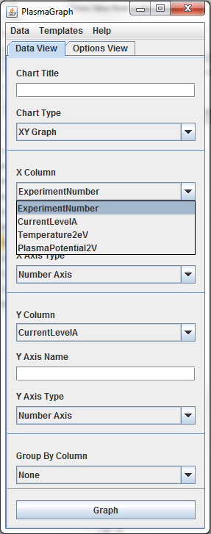

1. ***Select data set for the Y axis***

To choose which data is going to be represented in the X axis the tester must click on the X column option located in the tool bar. The column to be used for the X axis in this test case is PlasmaPotential2V.

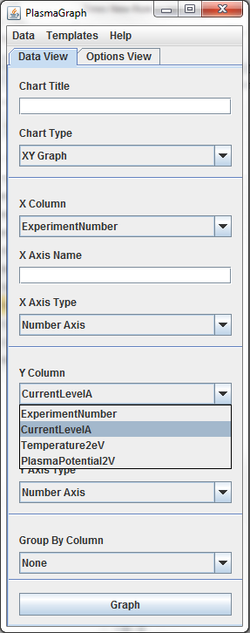

1. ***Create Graph***

To create the graph click on the “Graph” button located in the tool bar.

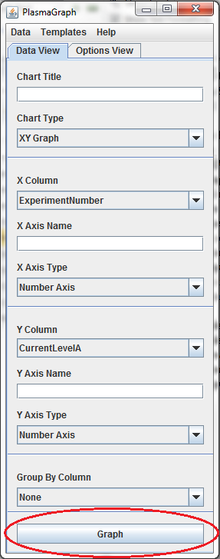

1. ***Compare outputs***

The tester must examine the graph produced by the program and determine if it complies with the expected output specified in the test case specification for this case ***[see document TCS-01-02 section 4]***.

1. ***Repeat for other OS***

Repeat steps 4.1 through 4.7 under the following operative systems:

1. Windows 7
2. Ubuntu Linux 14
3. Mac OS X

**System Test Summary Report**

* 1. **Test summary report identifier**

TSR-01-02 2014-05-22

* 1. **Summary**

The features “Import Data” and “Create Graph” as defined in the requirements documentation ***[*see *SRS-3-2014-05-15 section 2.2.1.1 and 2.2.1.4]*** passed all its tests.

The following test documents are associated with this module:

* STD-2-2014-05-15
* TDS-01-XX 2014-05-22
* TCS-01-01 2014-05-22
  1. **Tester details**

|  |  |  |  |
| --- | --- | --- | --- |
| Name | Test Started | Test Ended | Signature |
|  |  |  |  |

* 1. **Variances**

Indicate if there were any deviations from the original agreements on which this feature was supposed to be tested.

|  |  |  |
| --- | --- | --- |
|  |  |  |
|  |  |  |

* 1. **Evaluation**

Refer to the test case specification document TCS-02-02 2014-05-22 section 4 and indicate if the output generated by this test match the expected output.

|  |  |  |
| --- | --- | --- |
| Expected output | Yes | No |
| 1. The system produced the expected graph. |  |  |
| 1. The test was conducted in 5 minutes or less***.*** |  |  |

* 1. **Summary of results**

Indicate if the feature passed or failed the test. If it failed please indicate at which point and any possible cause for the issue.

|  |  |
| --- | --- |
|  |  |
|  |  |
|  |  |

* 1. **Approvals**

|  |  |  |
| --- | --- | --- |
|  |  |  |
|  |  |  |
| Daniel E. Quintini Greco |  | Date |

**System Test Case Specification**

* 1. **Test Case Specification Identifier**

TCS-01-03 2014-05-22

* 1. **Test Items**

PlasmaGraph feature “Choose Graph Options” **[see *SRS-3-2014-05-15 section 2.2.1.3*]**. The focus of this test will be on making sure that the graph title, X axis and Y axis label can be renamed by the user.

* 1. **Input Specifications**

1. One (1) data file formatted as a binary MATLAB Level 5 MAT-File **[see *SRS-3-2014-05-15 section 2.2.1.1*]** and having the following information:

|  |  |
| --- | --- |
| -- Column --  Name: ExperimentNumber  Type: double  Size: 5  Values: [NaN, 1.0, 1.0, 1.0, 2.0] | -- Column --  Name: CurrentLevelA  Type: double  Size: 5  Values: [50.0, 100.0, 150.0, 200.0, 250.0] |
| -- Column --  Name: Temperature2eV  Type: double  Size: 5  Values: [27.673172, 7.944175, 9.140306, 9.354156, 8.108458] | -- Column --  Name: PlasmaPotential2V  Type: double  Size: 5  Values: [44.4, 11.6, 12.8, 13.2, 12.0] |

1. One (1) column for the X axis. The variable selected must be Temperature2eV.
2. One (1) column for the Y axis. The variable selected must be PlasmaPotential2V.
3. Set the graph’s title to “Temperature Vs Plasma Potential (2V)”
4. Set X axis label to “Temperature”
5. Set Y axis label to “Plasma Potential”
   1. **Output Specifications**
6. The system must produce a graph with the following points plotted:

|  |  |
| --- | --- |
| Axis X | Axis Y |
| 7.944 | 11.6 |
| 8.108 | 12 |
| 9.14 | 12.8 |
| 9.654 | 13.2 |
| 27.673 | 44.4 |

* 1. **Environmental Needs**
  2. **Hardware**

A personal computer with the following minimal specifications is required to execute this case:

* 15’’ Monitor with a resolution of 1200x700 and refresh rate of 30Hz
* A standard alphanumeric American (QWERTY) keyboard
* Two 3.20Ghz microprocessors
* 500Mb of available HDD
* 512Mb of RAM
* One (1) USB 2.0 port
  1. **Software**

PlasmaGraph must be installed in the tester’s computer in order to perform this test case.

* 1. **Special Procedural Requirements**

This case must be executed in three (3) different operative systems as stated in the documentation STD-2-2014-05-15 these operative systems are:

1. Windows 7
2. Ubuntu Linux 14
3. Mac OS X 10

**System Test Procedure Specification**

* 1. **Test Case Specification Identifier**

TPS-01-03 2014-05-22

* 1. **Purpose**

This procedure describes the steps necessary to perform the test specified in the test design specification for PlasmaGraph feature “Choose Graph Options” TCS-01-03 **[see *TDS-01-XX section 2.2.1.3*]**.

* 1. **Special requirements**

No special requirements are needed to execute this test.

* 1. **Procedure steps**

1. ***Execute PlasmaGraph***

In order to launch the application the tester must click on the PlasmaGraph icon.

1. ***Import the data file provided into PlasmaGrap***

To import the data file provided the tester have to click on the data option located in the top menu of the tool bar. After doing this a menu with two more options will appear. Click on “Import Data”.



1. ***Select data set for the X axis***

To choose which data is going to be represented in the X axis the tester must click on the X column option located in the tool bar. The column to be used for the X axis in this test case is Temperature2eV.



1. ***Select data set for the Y axis***

To choose which data is going to be represented in the X axis the tester must click on the X column option located in the tool bar. The column to be used for the X axis in this test case is PlasmaPotential2V.



1. ***Change Graph Title***

To change the graph title click on the blank text field under the Chart Title option located in the tool bar and write “Temperature vs Plasma Potential (2V)”.

1. ***Change X Axis Label***

To change the X axis label click on the blank text field under the X axis name option located in the tool bar and write “Temperature”.

1. ***Change Y Axis Label***

To change the Y axis label click on the blank text field under the Y axis name option located in the tool bar and write “Plasma Potential”.

1. ***Create Graph***

To create the graph click on the “Graph” button located in the tool bar.



1. ***Compare outputs***

The tester must examine the graph produced by the program and determine if it complies with the expected output specified in the test case specification for this case ***[see document TCS-01-03 section 4]***.

1. ***Repeat for other OS***

Repeat steps 4.1 through 4.7 under the following operative systems:

1. Windows 7
2. Ubuntu Linux 14
3. Mac OS X 10

**System Test Summary Report**

* 1. **Test summary report identifier**

TSR-01-03 2014-05-22

* 1. **Summary**

The feature “Choose Graph Options” as defined in the requirements documentation ***[see SRS-3-2014-05-14 section 2.2.1.3]*** passed all its tests.

The following test documents are associated with this module:

* STD-2-2014-05-15
* TDS-01-XX 2014-05-22
* TCS-01-03 2014-05-22
  1. **Tester details**

|  |  |  |  |
| --- | --- | --- | --- |
| Name | Test Started | Test Ended | Signature |
|  |  |  |  |

* 1. **Variances**

Indicate if there were any deviations from the original agreements on which this feature was supposed to be tested.

|  |  |  |
| --- | --- | --- |
|  |  |  |
|  |  |  |

* 1. **Evaluation**

Refer to the test case specification document TCS-02-02 2014-05-22 section 4 and indicate if the output generated by this test match the expected output.

|  |  |  |
| --- | --- | --- |
| Expected output | Yes | No |
| 1. Graph with a specific set of points plotted ***[see TCS-01-03 2014-05-22 section 4].*** |  |  |
| 1. Graph that looks as specified by the test case document ***[see TCS-01-03 2014-05-22 section 4].*** |  |  |
| 1. Outputs a, b, and c matched as expected using Windows 7, Ubuntu Linux 14 and Mac OS X 10. |  |  |

* 1. **Summary of results**

Indicate if the feature passed or failed the test. If it failed please indicate at which point and any possible cause for the issue.

|  |  |
| --- | --- |
|  |  |
|  |  |
|  |  |

* 1. **Approvals**

|  |  |  |
| --- | --- | --- |
|  |  |  |
|  |  |  |
| Daniel E. Quintini Greco |  | Date |

**System Test Case Specification**

* 1. **Test Case Specification Identifier**

TCS-01-04 2014-05-22

* 1. **Test Items**

PlasmaGraph’s portability **[see *SRS-3-2014-05-15 section 3.5.4*]**.

* 1. **Input Specifications**

1. Documents TSR-01-01 to TSR-01-03 and TSR-02-01 to TSR-02-07.
   1. **Output Specifications**

The tester must examine these documents and make sure that every test specified in the input section passed its testing.

**System Test Summary Report**

* 1. **Test summary report identifier**

TSR-01-04 2014-05-22

* 1. **Summary**

PlasmaGraph’s portability feature as defined in the requirements documentation ***[see SRS-3-2014-05-14 section 3.5.4]*** passed all its tests.

The following test documents are associated with this module:

* STD-2-2014-05-15
* TDS-01-XX 2014-05-22
* TCS-01-04 2014-05-22
  1. **Tester details**

|  |  |  |  |
| --- | --- | --- | --- |
| Name | Test Started | Test Ended | Signature |
|  |  |  |  |

* 1. **Variances**

Indicate if there were any deviations from the original agreements on which this feature was supposed to be tested.

|  |  |  |
| --- | --- | --- |
|  |  |  |
|  |  |  |

* 1. **Evaluation**

Refer to the test case specification document TCS-01-04 2014-05-22 section 4 and indicate if the output generated by this test match the expected output.

|  |  |  |
| --- | --- | --- |
| Expected output | Yes | No |
| 1. All tests specified as input in TCS-01-04 successfully passed their tests. |  |  |

* 1. **Summary of results**

Indicate if the feature passed or failed the test. If it failed please indicate at which point and any possible cause for the issue.

|  |  |
| --- | --- |
|  |  |
|  |  |
|  |  |

* 1. **Approvals**

|  |  |  |
| --- | --- | --- |
|  |  |  |
|  |  |  |
| Daniel E. Quintini Greco |  | Date |

**System Test Design Specification**

1. **Purpose**

This document describes in more detail than the STD-2-2014-05-15 the process through which some of PlasmaGraph’s tests will be conducted. It discusses the features that are used to create graphs, and identifies the specific details of each operation being tested.

1. **Outline**
   1. **Test Design Specification Identifier**

TDS-02-XX 2014-05-22

* 1. **Features to be Tested**

1. Validate Data (FR-02) ***[see SRS-3-2014-05-15 section 2.2.1.2]***.

A.1 Remove invalid (X,Y) values.

A.2 Display message telling the user that the data file is invalid.

1. Choose Graph Options (FR-03) ***[see SRS-3-2014-05-15 section 2.2.1.3]***.

B.1 Choose the minimal options required for creating a graph.

B.2 Choose more than the minimal options required for creating a graph.

1. Create Graph (FR-04) ***[see SRS-3-2014-05-15 section 2.2.1.4]***.

C.1 Create a graph using two sets of values.

C.2 Create a graph with a linear interpolation using two sets of values.

C.3 Create a graph with a quadratic interpolation using two sets of values.

C.4 Create a graph with a spline interpolation using two sets of values.

C.5 Create a graph and identify its outliers.

C.6 Create a graph with any interpolation and determine its confidence level.

C.7 Create a graph with its (X,Y) values grouped using a third data set.

1. Save Graph (FR-05) ***[see SRS-3-2014-05-15 section 2.2.1.5]***.

D.1 Save a graph (in PNG format) in the user’s file system.

* 1. **Approach Refinements**
     1. **Testing Technique**

All features specified in section 2.2 of this document will be tested using the “Black Box” testing technique. This means that the testers will be oblivious of the system’s architecture and source code. The testers will interact with the system through its graphical user interface by providing inputs and examining outputs without knowing how and where the inputs are worked upon.

The black box testing technique was chosen for the following reasons:

* The testing comprises a very large segment of code.
* The testers need to be able to access all features being tested through a graphical user interface so access to the code is not required.
* The test must focus on the user’s perspective and not the developer’s. Visibly defined roles help achieve this goal.
  + 1. **Methods for Results Analysis**

The analysis for test cases derived from this specification will surround the system’s ability to produce graphs, save graphs and validate the data used to create graphs. To evaluate the success or failure of these test cases, the graph created by the system must be compared with the graph provided by the corresponding test case specification **[see section 2.5]**. In some test cases the success of the test isn’t determined exclusively by the graph produced by the system. Some test cases are considered passed based on the messages displayed by the system or the combination of graph and messages displayed by the system **[see section 2.5]**.

* + 1. **Common Test Cases Information**

All test cases derived from this specification must require that the testers repeats all test procedures using three (3) different operating systems and (3) different personal computers.

* 1. **Test Identification**

| Case Identifier | Description | Procedure |
| --- | --- | --- |
| TCS-02-01 | This case focusses on testing how the system creates the most basic type of graph and how it deals with NaN values in data files.  The data file used by the tester for this case must have one NaN value in each of its data sets.  This case covers features A.1, A.2, B.1, and C.1 as mentioned in section 2.2. | The tester must import a data file into the system and then order the system to create a graph using two (2) sets of values. One for the X axis and one for the Y axis. |
| TCS-02-02 | This case focusses on how the system creates graphs with linear interpolations and how the system determines the confidence level of a graph.  This case covers features B.1, B.2, C.1, C.2, and C.6 as mentioned in section 2.2. | The tester must import a data file into the system. Then the tester must order the system to create a graph identifying its confidence level, using a linear interpolation technique, and using two (2) sets of values. One for the X axis and one for the Y axis. |
| TCS-02-03 | This case focusses on how the system creates graphs with quadratic interpolations and how the system determines the confidence level of a graph.  This case covers features B.1, B.2, C.1, C.3, and C.6 as mentioned in section 2.2. | The tester must import a data file into the system. Then the tester must order the system to create a graph identifying its confidence level, using a quadratic interpolation technique, and using two (2) sets of values. One for the X axis and one for the Y axis. |
| TCS-02-04 | This case focusses on how the system creates graphs with spline interpolations and how the system determines the confidence level of a graph.  This case covers features B.1, B.2, C.1, C.4, and C.6 as mentioned in section 2.2. | The tester must import a data file into the system. Then the tester must order the system to create a graph identifying its confidence level, using a spline interpolation technique, and using two (2) sets of values. One for the X axis and one for the Y axis. |
| TCS-02-05 | This case focusses on how the system identifies outliers in a graph.  This case covers features B.1, B.2, C.1, and C.5 as mentioned in section 2.2. | The tester must import a data file into the system. Then the tester must order the system to create a graph using two (2) sets of values and identifying its outliers based on an arbitrary distance number provided by the tester.  Regarding the two sets of values selected. One must be assigned to the X axis and the other to the Y axis. |
| TCS-02-06 | This case focusses on how the system creates graphs with linear interpolations, how the system determines the confidence level of a graph and how the system groups pairs of (X,Y) values in a graph.  This case covers features B.1, B.2, C.1, C.2, C.6, and C.7 as mentioned in section 2.2. | The tester must import a data file into the system. Then the tester must order the system to create a graph using three (3) sets of values, a linear interpolation technique, and must identify the confidence level of the graph.  Regarding the sets of values selected. One must be assigned to the X axis, one to the Y axis, and one must be used for grouping (X,Y) pairs of values. |
| TCS-02-07 | This case focuses on how the system creates and saves graphs.  This case covers features B.1, C.1, and D.1 as mentioned in section 2.2. | The tester must import a data file into the system and then order the system to create a graph using two (2) sets of values. One for the X axis and one for the Y axis.  Finally, the tester must order the system to save that graph as an image in PNG format. |

* 1. **Features Pass/Fail Criteria**

Each feature will be considered a success if and only if it passes the following criteria for each of its cases:

* + 1. After running a case, the output provided to the tester by the system must match the expected output provided in the test case specification.
    2. No error messages are produced by the system unless the test case specification explicitly determines that an error message should be produced by the system.

**System Test Case Specification**

* 1. **Test Case Specification Identifier**

TCS-02-01 2014-05-22

* 1. **Test Items**

PlasmaGraph feature “Create Graph” using the minimal options **[see *SRS-3-2014-05-15 section 2.2.1.4*]**.

* 1. **Input Specifications**

1. One (1) data file formatted as a binary MATLAB Level 5 MAT-File **[see *SRS-3-2014-05-15 section 2.2.1.1*]** and having the following information:

|  |  |
| --- | --- |
| -- Column --  Name: ExperimentNumber  Type: double  Size: 5  Values: [NaN, 1.0, 1.0, 1.0, 2.0] | -- Column --  Name: CurrentLevelA  Type: double  Size: 5  Values: [50.0, 100.0, 150.0, 200.0, 250.0] |
| -- Column --  Name: Temperature2eV  Type: double  Size: 5  Values: [27.673172, 7.944175, 9.140306, 9.354156, 8.108458] | -- Column --  Name: PlasmaPotential2V  Type: double  Size: 5  Values: [44.4, 11.6, 12.8, 13.2, 12.0] |

1. One (1) column for the X axis. The variable selected must be ExperimentNumber.
2. One (1) column for the Y axis. The variable selected must be CurrentLevelA.
   1. **Output Specifications**
3. The system must show a message informing the user that there was one (1) row removed from the graph due to invalid data.
4. The system must produce a graph with the following points plotted:

|  |  |
| --- | --- |
| Axis X | Axis Y |
| 1 | 100 |
| 1 | 150 |
| 1 | 200 |
| 2 | 250 |

1. The graph must look like this:

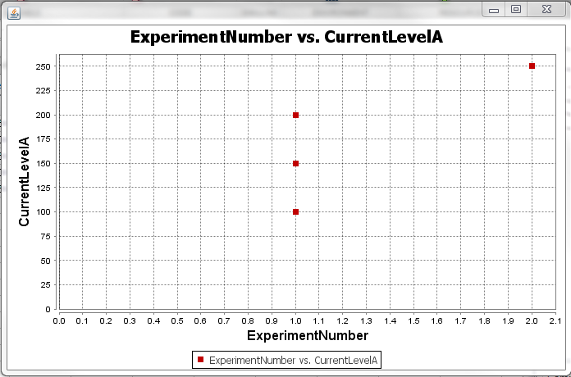

* 1. **Environmental Needs**
  2. **Hardware**

A personal computer with the following minimal specifications is required to execute this case:

* 15’’ Monitor with a resolution of 1200x700 and refresh rate of 30Hz
* A standard alphanumeric American (QWERTY) keyboard
* Two 3.20Ghz microprocessors
* 500Mb of available HDD
* 512Mb of RAM
* One (1) USB 2.0 port
  1. **Software**

PlasmaGraph must be installed in the tester’s computer in order to perform this test case.

* 1. **Special Procedural Requirements**

This case must be executed in three (3) different operative systems as stated in the documentation STD-2-2014-05-15 these operative systems are:

1. Windows 7
2. Ubuntu Linux 14
3. Mac OS X 10

**System Test Procedure Specification**

* 1. **Test Case Specification Identifier**

TPS-02-01

* 1. **Purpose**

This procedure describes the steps necessary to perform the test specified in the test design specification for PlasmaGraph feature “Create Graph” TCS-02-01 **[see *TDS-02-XX section 2.4*]**.

* 1. **Special requirements**

No special requirements are needed to execute this test.

* 1. **Procedure steps**

1. ***Execute PlasmaGraph***

In order to launch the application the tester must click on the PlasmaGraph icon.

1. ***Import the data file provided into PlasmaGrap***

To import the data file provided the tester have to click on the data option located in the top menu of the tool bar. After doing this a menu with two more options will appear. Click on “Import Data”.



1. ***Select data set for the X axis***

To choose which data is going to be represented in the X axis the tester must click on the X column option located in the tool bar. The column to be used for the X axis in this test case is ExperimentNumber.



1. ***Select data set for the Y axis***

To choose which data is going to be represented in the X axis the tester must click on the X column option located in the tool bar. The column to be used for the X axis in this test case is CurrentLevelA.



1. ***Create Graph***

To create the graph click on the “Graph” button located in the tool bar.



1. ***Compare outputs***

The tester must examine the graph produced by the program and determine if it complies with the expected output specified in the test case specification for this case ***[see document TCS-02-01 section 4]***.

1. ***Repeat for other OS***

Repeat steps 4.1 through 4.6 under the following operative systems:

1. Windows 7
2. Ubuntu Linux 14

Mac OS X 10

**System Test Summary Report**

* 1. **Test summary report identifier**

TSR-02-01 2014-05-22

* 1. **Summary**

The feature “Create Graph” as defined in the requirements documentation ***[see SRS-3-2014-05-14 section 2.2.1.4]*** passed all its tests.

The following test documents are associated with this module:

* STD-2-2014-05-15
* TDS-02-XX 2014-05-22
* TCS-02-01 2014-05-22
  1. **Tester details**

|  |  |  |  |
| --- | --- | --- | --- |
| Name | Test Started | Test Ended | Signature |
|  |  |  |  |

* 1. **Variances**

Indicate if there were any deviations from the original agreements on which this feature was supposed to be tested.

|  |  |  |
| --- | --- | --- |
|  |  |  |
|  |  |  |

* 1. **Evaluation**

Refer to the test case specification document TCS-02-01 2014-05-22 section 4 and indicate if the output generated by this test match the expected output.

|  |  |  |
| --- | --- | --- |
| Expected output | Yes | No |
| 1. Message informing the user that there was one (1) row removed from the graph due to invalid data. |  |  |
| 1. Graph with a specific set of points plotted ***[see TCS-02-01 2014-05-22 section 4].*** |  |  |
| 1. Graph that looks as specified by the test case document ***[see TCS-02-01 2014-05-22 section 4].*** |  |  |
| 1. Outputs a, b, and c matched as expected using Windows 7, Ubuntu Linux 14 and Mac OS X 10. |  |  |

* 1. **Summary of results**

Indicate if the feature passed or failed the test. If it failed please indicate at which point and any possible cause for the issue.

|  |  |
| --- | --- |
|  |  |
|  |  |
|  |  |

* 1. **Approvals**

|  |  |  |
| --- | --- | --- |
|  |  |  |
|  |  |  |
| Daniel E. Quintini Greco |  | Date |

**System Test Case Specification**

* 1. **Test Case Specification Identifier**

TCS-02-02 2014-05-22

* 1. **Test Items**

PlasmaGraph feature “Create Graph” using linear interpolation and determining confidence level **[see *SRS-3-2014-05-15 section 2.2.1.4*]**.

* 1. **Input Specifications**

1. One (1) data file formatted as a binary MATLAB Level 5 MAT-File **[see *SRS-3-2014-05-15 section 2.2.1.1*]** and having the following information:

|  |  |
| --- | --- |
| -- Column --  Name: ExperimentNumber  Type: double  Size: 5  Values: [NaN, 1.0, 1.0, 1.0, 2.0] | -- Column --  Name: CurrentLevelA  Type: double  Size: 5  Values: [50.0, 100.0, 150.0, 200.0, 250.0] |
| -- Column --  Name: Temperature2eV  Type: double  Size: 5  Values: [27.673172, 7.944175, 9.140306, 9.354156, 8.108458] | -- Column --  Name: PlasmaPotential2V  Type: double  Size: 5  Values: [44.4, 11.6, 12.8, 13.2, 12.0] |

1. One (1) column for the X axis. The variable selected must be Temperature2eV.
2. One (1) column for the Y axis. The variable selected must be PlasmaPotential2V.
   1. **Output Specifications**
3. The system must show a message informing the user that the graph “Temperature2eV vs PlasmaPotential2V” confidence level is 99%.
4. The system must produce a graph with the following points plotted:

|  |  |
| --- | --- |
| Axis X | Axis Y |
| 7.944 | 11.6 |
| 8.108 | 12 |
| 9.14 | 12.8 |
| 9.654 | 13.2 |
| 27.673 | 44.4 |

1. The graph must look like this:

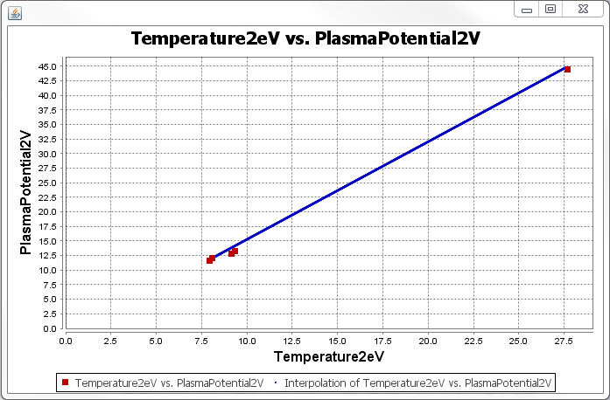

* 1. **Environmental Needs**
  2. **Hardware**

A personal computer with the following minimal specifications is required to execute this case:

* 15’’ Monitor with a resolution of 1200x700 and refresh rate of 30Hz
* A standard alphanumeric American (QWERTY) keyboard
* Two 3.20Ghz microprocessors
* 500Mb of available HDD
* 512Mb of RAM
* One (1) USB 2.0 port
  1. **Software**

PlasmaGraph must be installed in the tester’s computer in order to perform this test case.

* 1. **Special Procedural Requirements**

This case must be executed in three (3) different operative systems as stated in the documentation STD-2-2014-05-15 these operative systems are:

1. Windows 7
2. Ubuntu Linux 14
3. Mac OS X 10

**System Test Procedure Specification**

* 1. **Test Case Specification Identifier**

TPS-02-02 2014-05-22

* 1. **Purpose**

This procedure describes the steps necessary to perform the test specified in the test design specification for PlasmaGraph feature “Create Graph” TCS-02-01 **[see *TDS-02-XX section 2.4*]**.

* 1. **Special requirements**

No special requirements are needed to execute this test.

* 1. **Procedure steps**

1. ***Execute PlasmaGraph***

In order to launch the application the tester must click on the PlasmaGraph icon.

1. ***Import the data file provided into PlasmaGrap***

To import the data file provided the tester have to click on the data option located in the top menu of the tool bar. After doing this a menu with two more options will appear. Click on “Import Data”.



1. ***Select data set for the X axis***

To choose which data is going to be represented in the X axis the tester must click on the X column option located in the tool bar. The column to be used for the X axis in this test case is Temperature2eV.



1. ***Select data set for the Y axis***

To choose which data is going to be represented in the X axis the tester must click on the X column option located in the tool bar. The column to be used for the X axis in this test case is PlasmaPotential2V.



1. ***Choose interpolation***

Click on the “Options view” tab located in the tool bar and then choose “linear” from the interpolation type drop down menu.

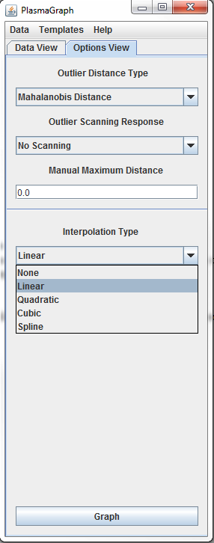

1. ***Create Graph***

To create the graph click on the “Graph” button located in the tool bar.



1. ***Compare outputs***

The tester must examine the graph produced by the program and determine if it complies with the expected output specified in the test case specification for this case ***[see document TCS-02-02 section 4]***.

1. ***Repeat for other OS***

Repeat steps 4.1 through 4.7 under the following operative systems:

1. Windows 7
2. Ubuntu Linux 14
3. Mac OS X 10

**System Test Summary Report**

* 1. **Test summary report identifier**

TSR-02-02 2014-05-22

* 1. **Summary**

The feature “Create Graph” as defined in the requirements documentation ***[see SRS-3-2014-05-14 section 2.2.1.4]*** passed all its tests.

The following test documents are associated with this module:

* STD-2-2014-05-15
* TDS-02-XX 2014-05-22
* TCS-02-01 2014-05-22
  1. **Tester details**

|  |  |  |  |
| --- | --- | --- | --- |
| Name | Test Started | Test Ended | Signature |
|  |  |  |  |

* 1. **Variances**

Indicate if there were any deviations from the original agreements on which this feature was supposed to be tested.

|  |  |  |
| --- | --- | --- |
|  |  |  |
|  |  |  |

* 1. **Evaluation**

Refer to the test case specification document TCS-02-02 2014-05-22 section 4 and indicate if the output generated by this test match the expected output.

|  |  |  |
| --- | --- | --- |
| Expected output | Yes | No |
| 1. Message informing the user that the graph “Temperature2eV vs PlasmaPotential2V” confidence level is 99%. |  |  |
| 1. Graph with a specific set of points plotted ***[see TCS-02-02 2014-05-22 section 4].*** |  |  |
| 1. Graph that looks as specified by the test case document ***[see TCS-02-02 2014-05-22 section 4].*** |  |  |
| 1. Outputs a, b, and c matched as expected using Windows 7, Ubuntu Linux 14 and Mac OS X 10. |  |  |

* 1. **Summary of results**

Indicate if the feature passed or failed the test. If it failed please indicate at which point and any possible cause for the issue.

|  |  |
| --- | --- |
|  |  |
|  |  |
|  |  |

* 1. **Approvals**

|  |  |  |
| --- | --- | --- |
|  |  |  |
|  |  |  |
| Daniel E. Quintini Greco |  | Date |

**System Test Case Specification**

* 1. **Test Case Specification Identifier**

TCS-02-03 2014-05-22

* 1. **Test Items**

PlasmaGraph feature “Create Graph” using linear interpolation and determining confidence level **[see *SRS-3-2014-05-15 section 2.2.1.4*]**.

* 1. **Input Specifications**

1. One (1) data file formatted as a binary MATLAB Level 5 MAT-File **[see *SRS-3-2014-05-15 section 2.2.1.1*]** and having the following information:

|  |  |
| --- | --- |
| -- Column --  Name: ExperimentNumber  Type: double  Size: 5  Values: [NaN, 1.0, 1.0, 1.0, 2.0] | -- Column --  Name: CurrentLevelA  Type: double  Size: 5  Values: [50.0, 100.0, 150.0, 200.0, 250.0] |
| -- Column --  Name: Temperature2eV  Type: double  Size: 5  Values: [27.673172, 7.944175, 9.140306, 9.354156, 8.108458] | -- Column --  Name: PlasmaPotential2V  Type: double  Size: 5  Values: [44.4, 11.6, 12.8, 13.2, 12.0] |

1. One (1) column for the X axis. The variable selected must be Temperature2eV.
2. One (1) column for the Y axis. The variable selected must be PlasmaPotential2V.
   1. **Output Specifications**
3. The system must show a message informing the R-squared value for regression “Temperature2eV vs PlasmaPotential2V” is 0.9999.
4. The system must produce a graph with the following points plotted:

|  |  |
| --- | --- |
| Axis X | Axis Y |
| 7.944 | 11.6 |
| 8.108 | 12 |
| 9.14 | 12.8 |
| 9.654 | 13.2 |
| 27.673 | 44.4 |

1. The graph must look like this:

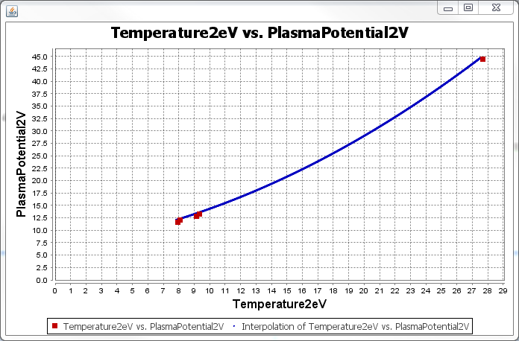

* 1. **Environmental Needs**
  2. **Hardware**

A personal computer with the following minimal specifications is required to execute this case:

* 15’’ Monitor with a resolution of 1200x700 and refresh rate of 30Hz
* A standard alphanumeric American (QWERTY) keyboard
* Two 3.20Ghz microprocessors
* 500Mb of available HDD
* 512Mb of RAM
* One (1) USB 2.0 port
  1. **Software**

PlasmaGraph must be installed in the tester’s computer in order to perform this test case.

* 1. **Special Procedural Requirements**

This case must be executed in three (3) different operative systems as stated in the documentation STD-2-2014-05-15 these operative systems are:

1. Windows 7
2. Ubuntu Linux 14
3. Mac OS X 10

**System Test Procedure Specification**

* 1. **Test Case Specification Identifier**

TPS-02-03 2014-05-22

* 1. **Purpose**

This procedure describes the steps necessary to perform the test specified in the test design specification for PlasmaGraph feature “Create Graph” TCS-02-01 **[see *TDS-02-XX section 2.4*]**.

* 1. **Special requirements**

No special requirements are needed to execute this test.

* 1. **Procedure steps**

1. ***Execute PlasmaGraph***

In order to launch the application the tester must click on the PlasmaGraph icon.

1. ***Import the data file provided into PlasmaGrap***

To import the data file provided the tester have to click on the data option located in the top menu of the tool bar. After doing this a menu with two more options will appear. Click on “Import Data”.



1. ***Select data set for the X axis***

To choose which data is going to be represented in the X axis the tester must click on the X column option located in the tool bar. The column to be used for the X axis in this test case is Temperature2eV.



1. ***Select data set for the Y axis***

To choose which data is going to be represented in the X axis the tester must click on the X column option located in the tool bar. The column to be used for the X axis in this test case is PlasmaPotential2V.



1. ***Choose interpolation***

Click on the “Options view” tab located in the tool bar and then choose “quadratic” from the interpolation type drop down menu.

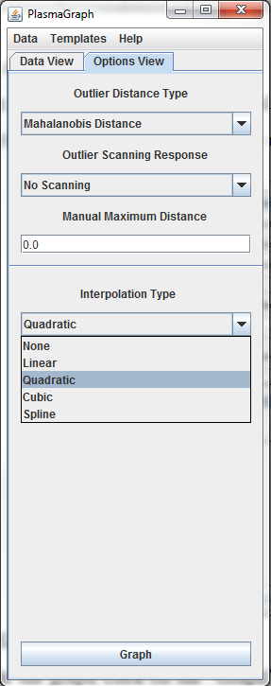

1. ***Create Graph***

To create the graph click on the “Graph” button located in the tool bar.



1. ***Compare outputs***

The tester must examine the graph produced by the program and determine if it complies with the expected output specified in the test case specification for this case ***[see document TCS-02-02 section 4]***.

1. ***Repeat for other OS***

Repeat steps 4.1 through 4.7 under the following operative systems:

1. Windows 7
2. Ubuntu Linux 14
3. Mac OS X 10

**System Test Summary Report**

* 1. **Test summary report identifier**

TSR-02-03 2014-05-22

* 1. **Summary**

The feature “Create Graph” as defined in the requirements documentation ***[see SRS-3-2014-05-14 section 2.2.1.4]*** passed all its tests.

The following test documents are associated with this module:

* STD-2-2014-05-15
* TDS-02-XX 2014-05-22
* TCS-02-01 2014-05-22
  1. **Tester details**

|  |  |  |  |
| --- | --- | --- | --- |
| Name | Test Started | Test Ended | Signature |
|  |  |  |  |

* 1. **Variances**

Indicate if there were any deviations from the original agreements on which this feature was supposed to be tested.

|  |  |  |
| --- | --- | --- |
|  |  |  |
|  |  |  |

* 1. **Evaluation**

Refer to the test case specification document TCS-02-02 2014-05-22 section 4 and indicate if the output generated by this test match the expected output.

|  |  |  |
| --- | --- | --- |
| Expected output | Yes | No |
| 1. Message informing the user that the R-squared value for regression “Temperature2eV vs PlasmaPotential2V” is 9.9999. |  |  |
| 1. Graph with a specific set of points plotted ***[see TCS-02-03 2014-05-22 section 4].*** |  |  |
| 1. Graph that looks as specified by the test case document ***[see TCS-02-03 2014-05-22 section 4].*** |  |  |
| 1. Outputs a, b, and c matched as expected using Windows 7, Ubuntu Linux 14 and Mac OS X 10. |  |  |

* 1. **Summary of results**

Indicate if the feature passed or failed the test. If it failed please indicate at which point and any possible cause for the issue.

|  |  |
| --- | --- |
|  |  |
|  |  |
|  |  |

* 1. **Approvals**

|  |  |  |
| --- | --- | --- |
|  |  |  |
|  |  |  |
| Daniel E. Quintini Greco |  | Date |

**System Test Case Specification**

* 1. **Test Case Specification Identifier**

TCS-02-04 2014-05-22

* 1. **Test Items**

PlasmaGraph feature “Create Graph” using linear interpolation and determining confidence level **[see *SRS-3-2014-05-15 section 2.2.1.4*]**.

* 1. **Input Specifications**

1. One (1) data file formatted as a binary MATLAB Level 5 MAT-File **[see *SRS-3-2014-05-15 section 2.2.1.1*]** and having the following information:

|  |  |
| --- | --- |
| -- Column --  Name: ExperimentNumber  Type: double  Size: 5  Values: [NaN, 1.0, 1.0, 1.0, 2.0] | -- Column --  Name: CurrentLevelA  Type: double  Size: 5  Values: [50.0, 100.0, 150.0, 200.0, 250.0] |
| -- Column --  Name: Temperature2eV  Type: double  Size: 5  Values: [27.673172, 7.944175, 9.140306, 9.354156, 8.108458] | -- Column --  Name: PlasmaPotential2V  Type: double  Size: 5  Values: [44.4, 11.6, 12.8, 13.2, 12.0] |

1. One (1) column for the X axis. The variable selected must be Temperature2eV.
2. One (1) column for the Y axis. The variable selected must be PlasmaPotential2V.
   1. **Output Specifications**
3. The system must show a message informing the R-squared value for regression “Temperature2eV vs PlasmaPotential2V” is 1.0.
4. The system must produce a graph with the following points plotted:

|  |  |
| --- | --- |
| Axis X | Axis Y |
| 7.944 | 11.6 |
| 8.108 | 12 |
| 9.14 | 12.8 |
| 9.654 | 13.2 |
| 27.673 | 44.4 |

1. The graph must look like this:

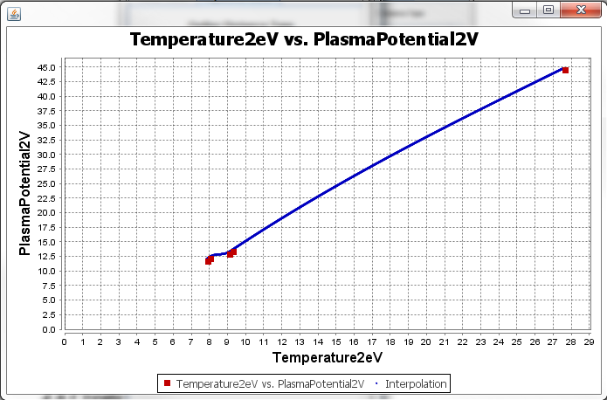

* 1. **Environmental Needs**
  2. **Hardware**

A personal computer with the following minimal specifications is required to execute this case:

* 15’’ Monitor with a resolution of 1200x700 and refresh rate of 30Hz
* A standard alphanumeric American (QWERTY) keyboard
* Two 3.20Ghz microprocessors
* 500Mb of available HDD
* 512Mb of RAM
* One (1) USB 2.0 port
  1. **Software**

PlasmaGraph must be installed in the tester’s computer in order to perform this test case.

* 1. **Special Procedural Requirements**

This case must be executed in three (3) different operative systems as stated in the documentation STD-2-2014-05-15 these operative systems are:

1. Windows 7
2. Ubuntu Linux 14
3. Mac OS X 10

**System Test Procedure Specification**

* 1. **Test Case Specification Identifier**

TPS-02-04 2014-05-22

* 1. **Purpose**

This procedure describes the steps necessary to perform the test specified in the test design specification for PlasmaGraph feature “Create Graph” TCS-02-04 **[see *TDS-02-XX section 2.4*]**.

* 1. **Special requirements**

No special requirements are needed to execute this test.

* 1. **Procedure steps**

1. ***Execute PlasmaGraph***

In order to launch the application the tester must click on the PlasmaGraph icon.

1. ***Import the data file provided into PlasmaGrap***

To import the data file provided the tester have to click on the data option located in the top menu of the tool bar. After doing this a menu with two more options will appear. Click on “Import Data”.



1. ***Select data set for the X axis***

To choose which data is going to be represented in the X axis the tester must click on the X column option located in the tool bar. The column to be used for the X axis in this test case is Temperature2eV.



1. ***Select data set for the Y axis***

To choose which data is going to be represented in the X axis the tester must click on the X column option located in the tool bar. The column to be used for the X axis in this test case is PlasmaPotential2V.



1. ***Choose interpolation***

Click on the “Options view” tab located in the tool bar and then choose “spline” from the interpolation type drop down menu.



1. ***Create Graph***

To create the graph click on the “Graph” button located in the tool bar.



1. ***Compare outputs***

The tester must examine the graph produced by the program and determine if it complies with the expected output specified in the test case specification for this case ***[see document TCS-02-04 section 4]***.

1. ***Repeat for other OS***

Repeat steps 4.1 through 4.7 under the following operative systems:

1. Windows 7
2. Ubuntu Linux 14
3. Mac OS X 10

**System Test Summary Report**

* 1. **Test summary report identifier**

TSR-02-04 2014-05-22

* 1. **Summary**

The feature “Create Graph” as defined in the requirements documentation ***[see SRS-3-2014-05-14 section 2.2.1.4]*** passed all its tests.

The following test documents are associated with this module:

* STD-2-2014-05-15
* TDS-02-XX 2014-05-22
* TCS-02-01 2014-05-22
  1. **Tester details**

|  |  |  |  |
| --- | --- | --- | --- |
| Name | Test Started | Test Ended | Signature |
|  |  |  |  |

* 1. **Variances**

Indicate if there were any deviations from the original agreements on which this feature was supposed to be tested.

|  |  |  |
| --- | --- | --- |
|  |  |  |
|  |  |  |

* 1. **Evaluation**

Refer to the test case specification document TCS-02-02 2014-05-22 section 4 and indicate if the output generated by this test match the expected output.

|  |  |  |
| --- | --- | --- |
| Expected output | Yes | No |
| 1. Message informing the user that the R-squared value for regression “Temperature2eV vs PlasmaPotential2V” is 1.0. |  |  |
| 1. Graph with a specific set of points plotted ***[see TCS-02-04 2014-05-22 section 4].*** |  |  |
| 1. Graph that looks as specified by the test case document ***[see TCS-02-04 2014-05-22 section 4].*** |  |  |
| 1. Outputs a, b, and c matched as expected using Windows 7, Ubuntu Linux 14 and Mac OS X 10. |  |  |

* 1. **Summary of results**

Indicate if the feature passed or failed the test. If it failed please indicate at which point and any possible cause for the issue.

|  |  |
| --- | --- |
|  |  |
|  |  |
|  |  |

* 1. **Approvals**

|  |  |  |
| --- | --- | --- |
|  |  |  |
|  |  |  |
| Daniel E. Quintini Greco |  | Date |

**System Test Case Specification**

* 1. **Test Case Specification Identifier**

TCS-02-05 2014-05-22

* 1. **Test Items**

PlasmaGraph feature “Create Graph” using linear interpolation and determining confidence level **[see *SRS-3-2014-05-15 section 2.2.1.4*]**.

* 1. **Input Specifications**

1. One (1) data file formatted as a binary MATLAB Level 5 MAT-File **[see *SRS-3-2014-05-15 section 2.2.1.1*]** and having the following information:

|  |  |
| --- | --- |
| -- Column --  Name: ExperimentNumber  Type: double  Size: 5  Values: [NaN, 1.0, 1.0, 1.0, 2.0] | -- Column --  Name: CurrentLevelA  Type: double  Size: 5  Values: [50.0, 100.0, 150.0, 200.0, 250.0] |
| -- Column --  Name: Temperature2eV  Type: double  Size: 5  Values: [27.673172, 7.944175, 9.140306, 9.354156, 8.108458] | -- Column --  Name: PlasmaPotential2V  Type: double  Size: 5  Values: [44.4, 11.6, 12.8, 13.2, 12.0] |

1. One (1) column for the X axis. The variable selected must be Temperature2eV.
2. One (1) column for the Y axis. The variable selected must be PlasmaPotential2V.
   1. **Output Specifications**
3. The system must show a message informing that it found an outlier at point (27.673, 44.4).
4. The system must produce a graph with the following points plotted:

|  |  |
| --- | --- |
| Axis X | Axis Y |
| 7.944 | 11.6 |
| 8.108 | 12 |
| 9.14 | 12.8 |
| 9.654 | 13.2 |
| 27.673 | 44.4 |

1. The graph must look like this:

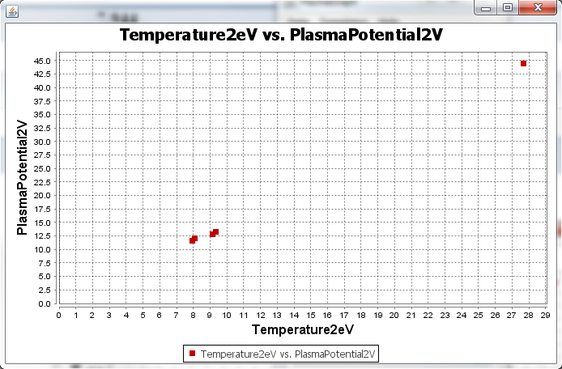

* 1. **Environmental Needs**
  2. **Hardware**

A personal computer with the following minimal specifications is required to execute this case:

* 15’’ Monitor with a resolution of 1200x700 and refresh rate of 30Hz
* A standard alphanumeric American (QWERTY) keyboard
* Two 3.20Ghz microprocessors
* 500Mb of available HDD
* 512Mb of RAM
* One (1) USB 2.0 port
  1. **Software**

PlasmaGraph must be installed in the tester’s computer in order to perform this test case.

* 1. **Special Procedural Requirements**

This case must be executed in three (3) different operative systems as stated in the documentation STD-2-2014-05-15 these operative systems are:

1. Windows 7
2. Ubuntu Linux 14
3. Mac OS X 10

**System Test Procedure Specification**

* 1. **Test Case Specification Identifier**

TPS-02-05 2014-05-22

* 1. **Purpose**

This procedure describes the steps necessary to perform the test specified in the test design specification for PlasmaGraph feature “Create Graph” TCS-02-05 **[see *TDS-02-XX section 2.4*]**.

* 1. **Special requirements**

No special requirements are needed to execute this test.

* 1. **Procedure steps**

1. ***Execute PlasmaGraph***

In order to launch the application the tester must click on the PlasmaGraph icon.

1. ***Import the data file provided into PlasmaGrap***

To import the data file provided the tester have to click on the data option located in the top menu of the tool bar. After doing this a menu with two more options will appear. Click on “Import Data”.



1. ***Select data set for the X axis***

To choose which data is going to be represented in the X axis the tester must click on the X column option located in the tool bar. The column to be used for the X axis in this test case is Temperature2eV.



1. ***Select data set for the Y axis***

To choose which data is going to be represented in the X axis the tester must click on the X column option located in the tool bar. The column to be used for the X axis in this test case is PlasmaPotential2V.



1. ***Configure outlier detection***

Click on the “Options view” tab located in the tool bar and then choose “User-Provided distance” from the outlier distance type drop down menu. Choose “warn” from the outlier scanning response drop down menu and enter the number ten (10) in the text box below the title “Manual Maximum Distance”.

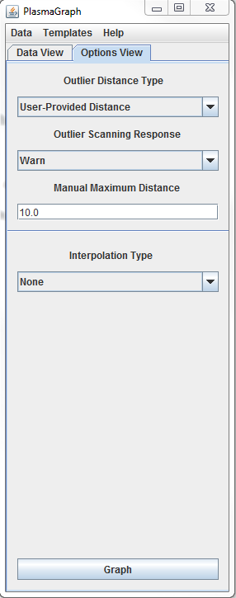

1. ***Create Graph***

To create the graph click on the “Graph” button located in the tool bar.



1. ***Compare outputs***

The tester must examine the graph produced by the program and determine if it complies with the expected output specified in the test case specification for this case ***[see document TCS-02-05 section 4]***.

1. ***Repeat for other OS***

Repeat steps 4.1 through 4.7 under the following operative systems:

1. Windows 7
2. Ubuntu Linux 14
3. Mac OS X 10

**System Test Summary Report**

* 1. **Test summary report identifier**

TSR-02-05 2014-05-22

* 1. **Summary**

The feature “Create Graph” as defined in the requirements documentation ***[see SRS-3-2014-05-14 section 2.2.1.4]*** passed all its tests.

The following test documents are associated with this module:

* STD-2-2014-05-15
* TDS-02-XX 2014-05-22
* TCS-02-01 2014-05-22
  1. **Tester details**

|  |  |  |  |
| --- | --- | --- | --- |
| Name | Test Started | Test Ended | Signature |
|  |  |  |  |

* 1. **Variances**

Indicate if there were any deviations from the original agreements on which this feature was supposed to be tested.

|  |  |  |
| --- | --- | --- |
|  |  |  |
|  |  |  |

* 1. **Evaluation**

Refer to the test case specification document TCS-02-02 2014-05-22 section 4 and indicate if the output generated by this test match the expected output.

|  |  |  |
| --- | --- | --- |
| Expected output | Yes | No |
| 1. Message informing the user that it found an outlier at point (27.673, 44.4). |  |  |
| 1. Graph with a specific set of points plotted ***[see TCS-02-05 2014-05-22 section 4].*** |  |  |
| 1. Graph that looks as specified by the test case document ***[see TCS-02-05 2014-05-22 section 4].*** |  |  |
| 1. Outputs a, b, and c matched as expected using Windows 7, Ubuntu Linux 14 and Mac OS X 10. |  |  |

* 1. **Summary of results**

Indicate if the feature passed or failed the test. If it failed please indicate at which point and any possible cause for the issue.

|  |  |
| --- | --- |
|  |  |
|  |  |
|  |  |

* 1. **Approvals**

|  |  |  |
| --- | --- | --- |
|  |  |  |
|  |  |  |
| Daniel E. Quintini Greco |  | Date |

**System Test Case Specification**

* 1. **Test Case Specification Identifier**

TCS-02-06 2014-05-22

* 1. **Test Items**

PlasmaGraph feature “Create Graph” using the minimal options **[see *SRS-3-2014-05-15 section 2.2.1.4*]**.

* 1. **Input Specifications**

1. One (1) data file formatted as a binary MATLAB Level 5 MAT-File **[see *SRS-3-2014-05-15 section 2.2.1.1*]** and having the following information:

|  |  |
| --- | --- |
| -- Column --  Name: ExperimentNumber  Type: double  Size: 5  Values: [NaN, 1.0, 1.0, 1.0, 2.0] | -- Column --  Name: CurrentLevelA  Type: double  Size: 5  Values: [50.0, 100.0, 150.0, 200.0, 250.0] |
| -- Column --  Name: Temperature2eV  Type: double  Size: 5  Values: [27.673172, 7.944175, 9.140306, 9.354156, 8.108458] | -- Column --  Name: PlasmaPotential2V  Type: double  Size: 5  Values: [44.4, 11.6, 12.8, 13.2, 12.0] |

1. One (1) column for the X axis. The variable selected must be Temperature2eV.
2. One (1) column for the Y axis. The variable selected must be PlasmaPotential2V.
3. One (1) column for grouping. The variable selected must be ExperimentNumber.
   1. **Output Specifications**
4. The system must show a message informing the user that there was one (1) row removed from the graph due to invalid data.
5. The system must produce a graph with the following points plotted:

|  |  |  |
| --- | --- | --- |
| Group | Axis X | Axis Y |
| 1 | 7.944 | 11.6 |
| 2 | 8.108 | 12 |
| 1 | 9.14 | 12.8 |
| 1 | **9.354** | 13.2 |

1. The graph must look like this:

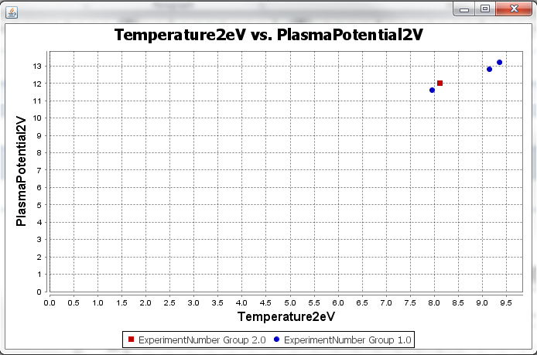

* 1. **Environmental Needs**
  2. **Hardware**

A personal computer with the following minimal specifications is required to execute this case:

* 15’’ Monitor with a resolution of 1200x700 and refresh rate of 30Hz
* A standard alphanumeric American (QWERTY) keyboard
* Two 3.20Ghz microprocessors
* 500Mb of available HDD
* 512Mb of RAM
* One (1) USB 2.0 port
  1. **Software**

PlasmaGraph must be installed in the tester’s computer in order to perform this test case.

* 1. **Special Procedural Requirements**

This case must be executed in three (3) different operative systems as stated in the documentation STD-2-2014-05-15 these operative systems are:

1. Windows 7
2. Ubuntu Linux 14
3. Mac OS X 10

**System Test Procedure Specification**

* 1. **Test Case Specification Identifier**

TPS-02-06 2014-05-22

* 1. **Purpose**

This procedure describes the steps necessary to perform the test specified in the test design specification for PlasmaGraph feature “Create Graph” TCS-02-06 **[see *TDS-02-XX section 2.4*]**.

* 1. **Special requirements**

No special requirements are needed to execute this test.

* 1. **Procedure steps**

1. ***Execute PlasmaGraph***

In order to launch the application the tester must click on the PlasmaGraph icon.

1. ***Import the data file provided into PlasmaGrap***

To import the data file provided the tester have to click on the data option located in the top menu of the tool bar. After doing this a menu with two more options will appear. Click on “Import Data”.



1. ***Select data set for the X axis***

To choose which data is going to be represented in the X axis the tester must click on the X column option located in the tool bar. The column to be used for the X axis in this test case is Temperature2eV.



1. ***Select data set for the Y axis***

To choose which data is going to be represented in the X axis the tester must click on the X column option located in the tool bar. The column to be used for the X axis in this test case is PlasmaPotential2V.



1. ***Create Graph***

To choose which data is going to be used for grouping the tester must click on the Group By column option located in the tool bar. The column to be used in this test case is ExperimentNumber.

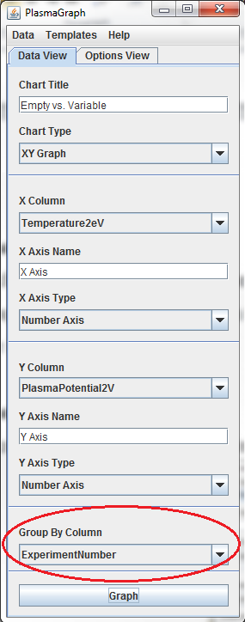

1. ***Create Graph***

To create the graph click on the “Graph” button located in the tool bar.



1. ***Compare outputs***

The tester must examine the graph produced by the program and determine if it complies with the expected output specified in the test case specification for this case ***[see document TCS-02-06 section 4]***.

1. ***Repeat for other OS***

Repeat steps 4.1 through 4.6 under the following operative systems:

1. Windows 7
2. Ubuntu Linux 14
3. Mac OS X 10

**System Test Summary Report**

* 1. **Test summary report identifier**

TSR-02-06 2014-05-22

* 1. **Summary**

The feature “Create Graph” as defined in the requirements documentation ***[see SRS-3-2014-05-14 section 2.2.1.4]*** passed all its tests.

The following test documents are associated with this module:

* STD-2-2014-05-15
* TDS-02-XX 2014-05-22
* TCS-02-06 2014-05-22
  1. **Tester details**

|  |  |  |  |
| --- | --- | --- | --- |
| Name | Test Started | Test Ended | Signature |
|  |  |  |  |

* 1. **Variances**

Indicate if there were any deviations from the original agreements on which this feature was supposed to be tested.

|  |  |  |
| --- | --- | --- |
|  |  |  |
|  |  |  |

* 1. **Evaluation**

Refer to the test case specification document TCS-02-01 2014-05-22 section 4 and indicate if the output generated by this test match the expected output.

|  |  |  |
| --- | --- | --- |
| Expected output | Yes | No |
| 1. Message informing the user that there was one (1) row removed from the graph due to invalid data. |  |  |
| 1. Graph with a specific set of points plotted ***[see TCS-02-06 2014-05-22 section 4].*** |  |  |
| 1. Graph that looks as specified by the test case document ***[see TCS-02-06 2014-05-22 section 4].*** |  |  |
| 1. Outputs a, b, and c matched as expected using Windows 7, Ubuntu Linux 14 and Mac OS X 10. |  |  |

* 1. **Summary of results**

Indicate if the feature passed or failed the test. If it failed please indicate at which point and any possible cause for the issue.

|  |  |
| --- | --- |
|  |  |
|  |  |
|  |  |

* 1. **Approvals**

|  |  |  |
| --- | --- | --- |
|  |  |  |
|  |  |  |
| Daniel E. Quintini Greco |  | Date |

**System Test Case Specification**

* 1. **Test Case Specification Identifier**

TCS-02-07 2014-05-22

* 1. **Test Items**

PlasmaGraph feature “Create Graph” using the minimal options **[see *SRS-3-2014-05-15 section 2.2.1.4*]**.

* 1. **Input Specifications**

1. One (1) data file formatted as a binary MATLAB Level 5 MAT-File **[see *SRS-3-2014-05-15 section 2.2.1.1*]** and having the following information:

|  |  |
| --- | --- |
| -- Column --  Name: ExperimentNumber  Type: double  Size: 5  Values: [NaN, 1.0, 1.0, 1.0, 2.0] | -- Column --  Name: CurrentLevelA  Type: double  Size: 5  Values: [50.0, 100.0, 150.0, 200.0, 250.0] |
| -- Column --  Name: Temperature2eV  Type: double  Size: 5  Values: [27.673172, 7.944175, 9.140306, 9.354156, 8.108458] | -- Column --  Name: PlasmaPotential2V  Type: double  Size: 5  Values: [44.4, 11.6, 12.8, 13.2, 12.0] |

1. One (1) column for the X axis. The variable selected must be ExperimentNumber.
2. One (1) column for the Y axis. The variable selected must be CurrentLevelA.
   1. **Output Specifications**
3. The system must show a message informing the user that there was one (1) row removed from the graph due to invalid data.
4. The system must produce a graph with the following points plotted:

|  |  |
| --- | --- |
| Axis X | Axis Y |
| 1 | 100 |
| 1 | 150 |
| 1 | 200 |
| 2 | 250 |

1. The graph must be saved in the tester’s computer in PNG format and it must look like this:
   1. **Environmental Needs**
   2. **Hardware**

A personal computer with the following minimal specifications is required to execute this case:

* 15’’ Monitor with a resolution of 1200x700 and refresh rate of 30Hz
* A standard alphanumeric American (QWERTY) keyboard
* Two 3.20Ghz microprocessors
* 500Mb of available HDD
* 512Mb of RAM
* One (1) USB 2.0 port
  1. **Software**

PlasmaGraph must be installed in the tester’s computer in order to perform this test case.

* 1. **Special Procedural Requirements**

This case must be executed in three (3) different operative systems as stated in the documentation STD-2-2014-05-15 these operative systems are:

1. Windows 7
2. Ubuntu Linux 14
3. Mac OS X 10

**System Test Procedure Specification**

* 1. **Test Case Specification Identifier**

TPS-02-07 2014-05-22

* 1. **Purpose**

This procedure describes the steps necessary to perform the test specified in the test design specification for PlasmaGraph feature “Create Graph” TCS-02-07 **[see *TDS-02-XX section 2.4*]**.

* 1. **Special requirements**

No special requirements are needed to execute this test.

* 1. **Procedure steps**

1. ***Execute PlasmaGraph***

In order to launch the application the tester must click on the PlasmaGraph icon.

1. ***Import the data file provided into PlasmaGrap***

To import the data file provided the tester have to click on the data option located in the top menu of the tool bar. After doing this a menu with two more options will appear. Click on “Import Data”.



1. ***Select data set for the X axis***

To choose which data is going to be represented in the X axis the tester must click on the X column option located in the tool bar. The column to be used for the X axis in this test case is ExperimentNumber.



1. ***Select data set for the Y axis***

To choose which data is going to be represented in the X axis the tester must click on the X column option located in the tool bar. The column to be used for the X axis in this test case is CurrentLevelA.



1. ***Create Graph***

To create the graph click on the “Graph” button located in the tool bar.



1. ***Save graph***

To save the graph right click on the graph pane and choose save as PNG.

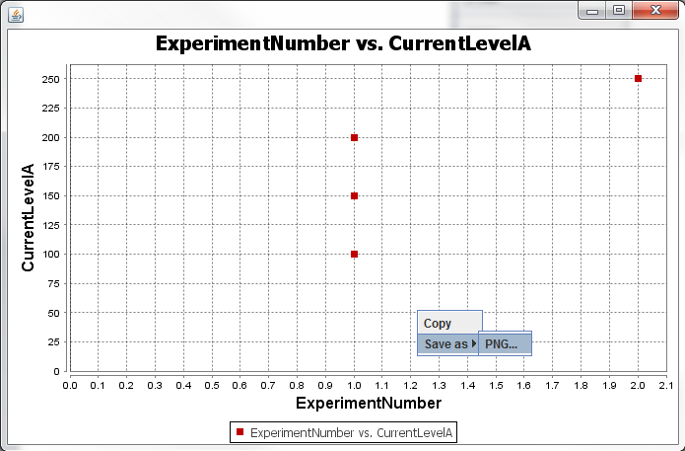

1. ***Compare outputs***

The tester must examine the graph produced by the program and determine if it complies with the expected output specified in the test case specification for this case ***[see document TCS-02-07 section 4]***.

1. ***Repeat for other OS***

Repeat steps 4.1 through 4.6 under the following operative systems:

1. Windows 7
2. Ubuntu Linux 14
3. Mac OS X 10

**System Test Summary Report**

* 1. **Test summary report identifier**

TSR-02-07 2014-05-22

* 1. **Summary**

The feature “Create Graph” as defined in the requirements documentation ***[see SRS-3-2014-05-14 section 2.2.1.4]*** passed all its tests.

The following test documents are associated with this module:

* STD-2-2014-05-15
* TDS-02-XX 2014-05-22
* TCS-02-07 2014-05-22
  1. **Tester details**

|  |  |  |  |
| --- | --- | --- | --- |
| Name | Test Started | Test Ended | Signature |
|  |  |  |  |

* 1. **Variances**

Indicate if there were any deviations from the original agreements on which this feature was supposed to be tested.

|  |  |  |
| --- | --- | --- |
|  |  |  |
|  |  |  |

* 1. **Evaluation**

Refer to the test case specification document TCS-02-07 2014-05-22 section 4 and indicate if the output generated by this test match the expected output.

|  |  |  |
| --- | --- | --- |
| Expected output | Yes | No |
| 1. Message informing the user that there was one (1) row removed from the graph due to invalid data. |  |  |
| 1. Graph with a specific set of points plotted ***[see TCS-02-07 2014-05-22 section 4].*** |  |  |
| 1. Graph was saved and looks as specified by the test case document ***[see TCS-02-07 2014-05-22 section 4].*** |  |  |
| 1. Outputs a, b, and c matched as expected using Windows 7, Ubuntu Linux 14 and Mac OS X 10. |  |  |

* 1. **Summary of results**

Indicate if the feature passed or failed the test. If it failed please indicate at which point and any possible cause for the issue.

|  |  |
| --- | --- |
|  |  |
|  |  |
|  |  |

* 1. **Approvals**

|  |  |  |
| --- | --- | --- |
|  |  |  |
|  |  |  |
| Daniel E. Quintini Greco |  | Date |

**System Test Design Specification**

1. **Purpose**

This document describes in more detail than the STD-2-2014-05-15 how the Java packages of PlasmaGraph are going to be tested.

1. **Outline**
   1. **Test Design Specification Identifier**

TDS-03-01 2014-05-22

* 1. **Features to be Tested**

1. Automated Test Suit

A.1 HeaderDataTest.

A.2 InterpolatorTest.

A.3 MATTest.

A.4 OutlierSearchTest.

A.5 TemplateTest.

* 1. **Approach Refinements**
     1. **Testing Technique**

All features specified in section 2.2 of this document will be tested using the “White Box” testing technique. This means that the testers will have access to the system’s architecture and source code. The testers will interact with the system through Eclipse integrated development environment which provides comprehensive facilities to computer programmer.

The white box testing technique was chosen for the following reasons:

* These were the first set of tests and because the tester has knowledge of the source code it becomes possible to determine which data can help in further testing.
  + 1. **Methods for Results Analysis**

The analysis for this test case will be done using the output produced by the JUnit console. This output includes the following information:

* + Segments of code being tested.
  + Segments of code that produced errors.
  + Segments of code that produced failures.
  1. **Features Pass/Fail Criteria**

The only requirement to pass this test is that the output produced by JUnit does not present any failures.

**System Test Case Specification**

* 1. **Test Case Specification Identifier**

TCS-03-01 2014-05-22

* 1. **Test Items**

Feature test suite **[see *STD-3-2014-06-02 section 3.1*]**.

* 1. **Input Specifications**

The input for this test is generated automatically.

* 1. **Output Specifications**

1. All test packages must execute without failures. The output provided by JUnit ***[see TPS-03-01]*** must match that of figure 1.

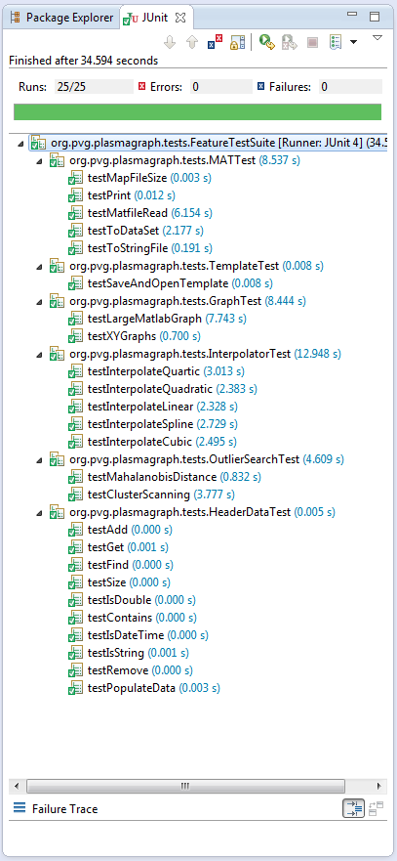

Figure 1: JUnit expected output

* 1. **Environmental Needs**
  2. **Hardware**

A personal computer with the following minimal specifications is required to execute this case:

* 15’’ Monitor with a resolution of 1200x700 and refresh rate of 30Hz
* A standard alphanumeric American (QWERTY) keyboard
* Two 3.20Ghz microprocessors
* 500Mb of available HDD
* 512Mb of RAM
* One (1) USB 2.0 port
  1. **Software**

PlasmaGraph must be installed in the tester’s computer in order to perform this test case.

**System Test Procedure Specification**

* 1. **Test Case Specification Identifier**

TPS-03-01 2014-05-22

* 1. **Purpose**

This procedure describes the steps necessary to perform the test specified in the test design specification for PlasmaGraph TCS-03-01.

* 1. **Special requirements**

The tester must have knowledge of the system source code and access to it. Also, the tester must have Eclipse IDE installed as well as the testing framework JUnit.

* 1. **Procedure steps**

1. ***Open Eclipse***

The first step is to open Eclipse IDE.

1. ***Import PlasmaGraph Project***

To import the project right click on the Package Explorer and choose import.

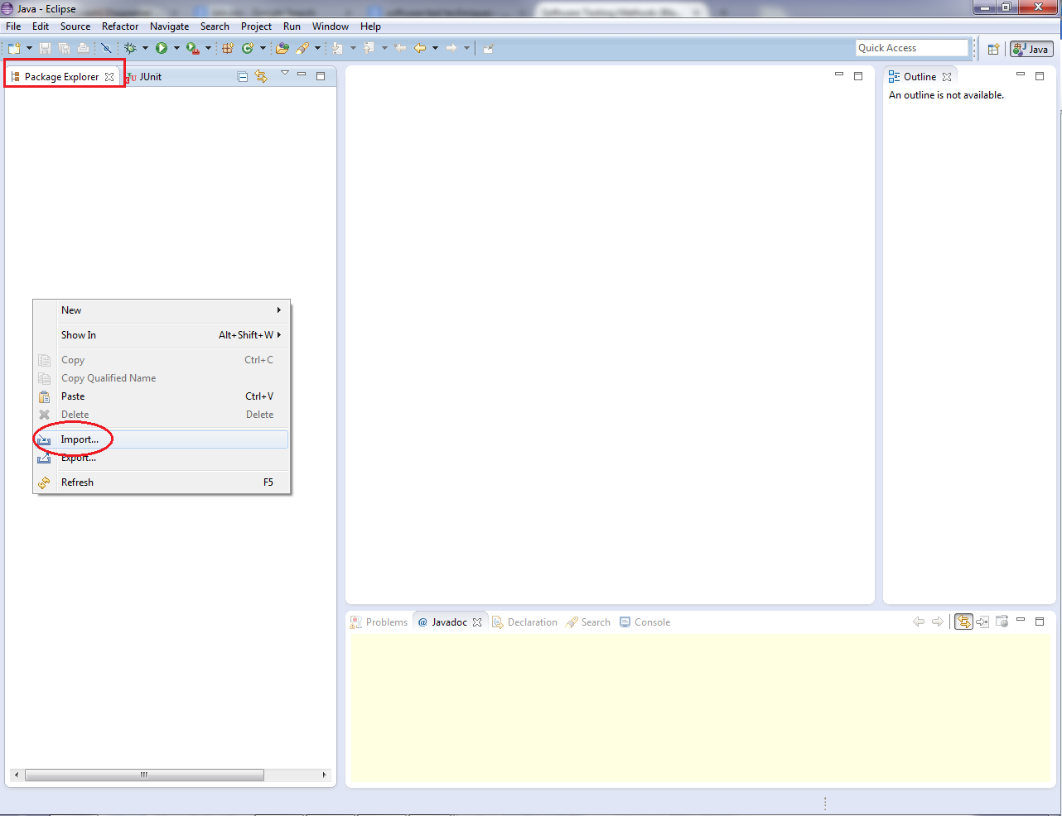

A window with several folders will appear. Select the folder called “General”, this will give you access to the options inside the folder. Choose “Existing Projects into Workspace” and click “Next”.

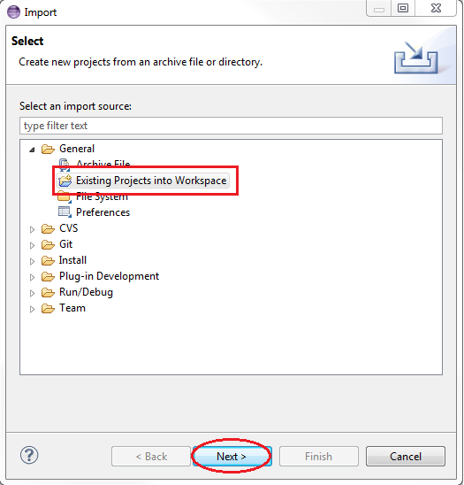

After clicking on next a new window with more options will appear. Click on the button that says “Browse…” located next to “Select root directory”. This action will prompt a window that you will use to select the directory where the source code of PlasmaGraph is.

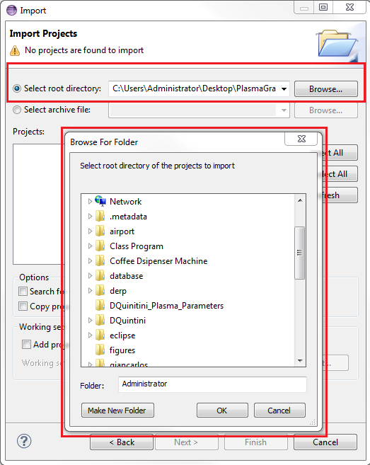

Now make sure that “plasmagraph” is selected under projects and click “Finish”.

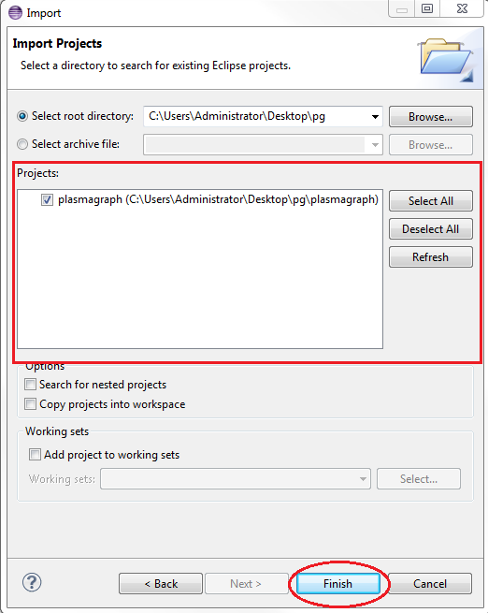

1. ***Run test suit***

To run the automated tests, go to the package explorer double click on plasmagraph to see what is inside the package. Then double click on src, org.pvg.plasmagraph.tests and finally right click on FeatureTestSuite.java.

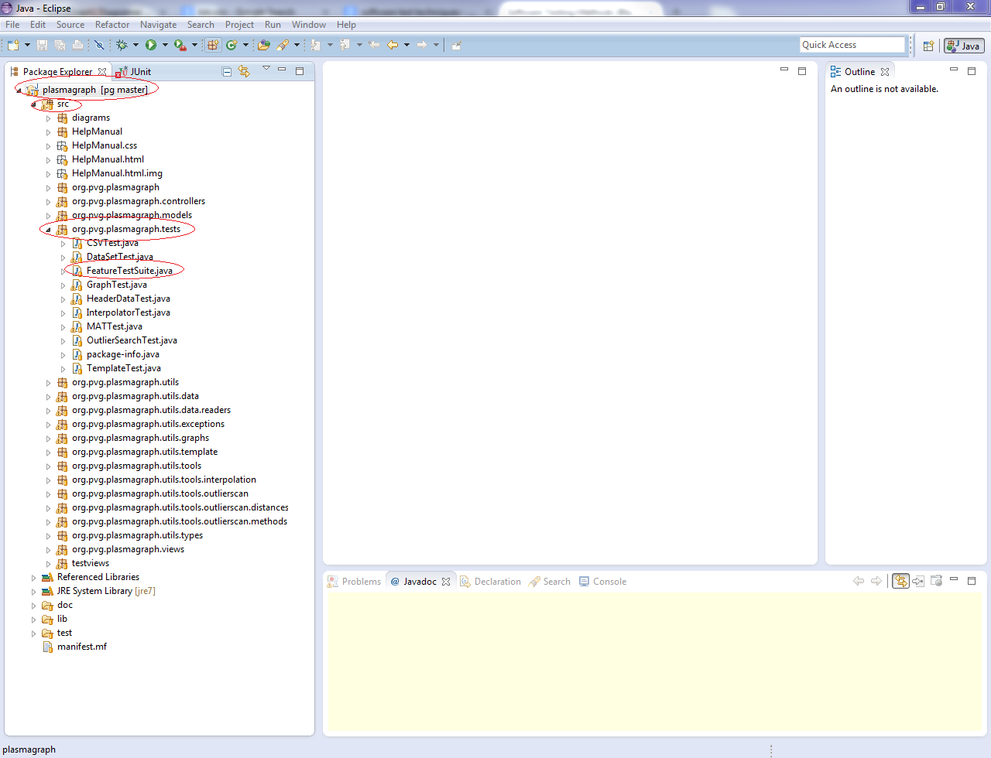

After right click on FeatureTestSuite.java a new menu window will appear. Choose “Run As >> JUnit Test”

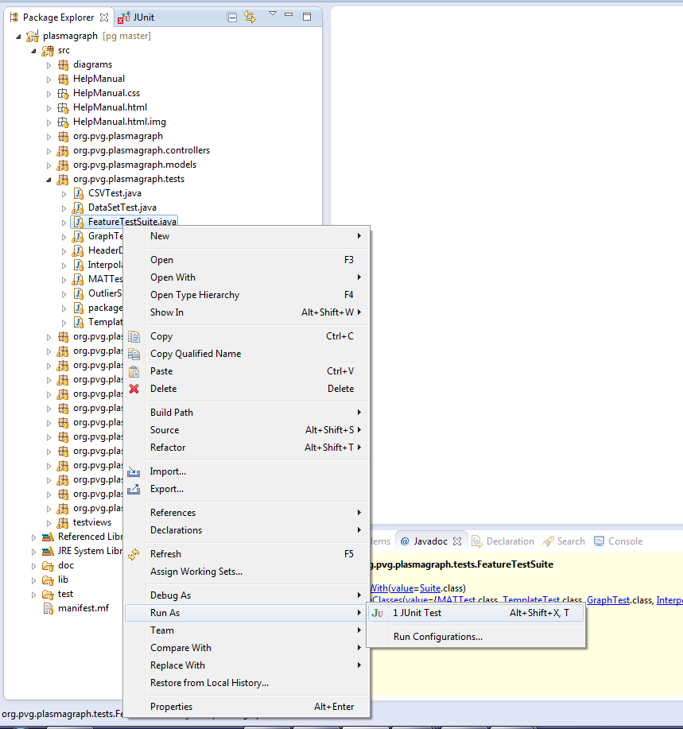

1. ***Compare outputs***

The tester must examine the output produced by JUnit and determine if it complies with the expected output specified in the test case specification for this case ***[see document TCS-03-01 section 4]***. To review this output click on the tab called “JUnit” located next to the package explorer tab.



**System Test Summary Report**

* 1. **Test summary report identifier**

TSR-03-01 2014-05-22

* 1. **Summary**

Determine if the features tested by TCS-03-01 passed comprehensive testing.

The following test documents are associated with this module:

* STD-2-2014-05-15
* TDS-03-01 2014-05-22
* TCS-03-01 2014-05-22
  1. **Tester details**

|  |  |  |  |
| --- | --- | --- | --- |
| Name | Test Started | Test Ended | Signature |
|  |  |  |  |

* 1. **Variances**

Indicate if there were any deviations from the original agreements on which this feature was supposed to be tested.

|  |  |  |
| --- | --- | --- |
|  |  |  |
|  |  |  |

* 1. **Evaluation**

Refer to the test case specification document TCS-03-01 2014-05-22 section 4 and indicate if the output generated by this test match the expected output.

|  |  |  |
| --- | --- | --- |
| Expected output | Yes | No |
| 1. The output produced by JUnit didn’t mention any failures. |  |  |

* 1. **Summary of results**

Indicate if the feature passed or failed the test. If it failed please indicate at which point and any possible cause for the issue.

|  |  |
| --- | --- |
|  |  |
|  |  |
|  |  |

* 1. **Approvals**

|  |  |  |
| --- | --- | --- |
|  |  |  |
|  |  |  |
| Daniel E. Quintini Greco |  | Date |